*­­*

|  |  |  |
| --- | --- | --- |
| **شعار جامعة بنها الجديد**f |  |  |
| **Benha University** |  | **Faculty of Computers & Artificial Intelligence** |

**Oncology Center Services and Prediction Techniques to Assist in Making Right Decision.**

A senior project submitted in partial fulfillment of the requirements for the degree of Bachelor of Computers and Artificial Intelligence.

**Medical Informatics Departement,**

***Project Team***

1. Alaa Walid Mohamed Alshitany
2. Eman Tarek Taha Ali
3. Basma Talaat Mahmoud Mohamed
4. Abdelrahman Ahmed Abdelhady
5. Yara Ahmed Mohamed Swisa

***Under Supervision of***

**Prof. Dr.Elsayed Badr**

Benha. January 2023

DECLARATION

We hereby certify that this material, which we now submit for assessment on the program of study leading to the award of Bachelor of Computers and Artificial Intelligence. we have exercised reasonable care to ensure that the work is original and does not to the best of our knowledge breach any law of copyright and has not been taken from the work of others save and to the extent that such work has been cited and acknowledged within the text of our work.

**Signed:** \_\_\_\_\_\_\_\_\_\_\_\_\_\_\_\_\_\_\_\_\_\_\_\_\_\_\_\_\_

**Date:** 15, Feb 2023.

ABSTRACT

Cancer is any disease among many diseases characterized by the development of abnormal cells that divide uncontrollably and is the leading cause of death for 10 million people, or approximately one death in every 6 deaths. Accurate prediction of response to cancer drugs is difficult due to uncertainty of drug efficacy and heterogeneity of cancer patients. Due to It is one of the most dangerous diseases that affect humans, so highlighting tumor’s centers and paying attention to solving existing problems is important and necessary, and this is what we try to do in our project. We try to organize the process of making appointments and help doctors to choose the right drug efficiently using the deep learning model.

We have integrated 2 public databases in our study: GDSC and CCLE In our study, we operate on 256 genes and 238 drugs. GDSC database provides us IC50 values for large-scale drug screening data, when IC50 value is small, it is evidence that the effectiveness of the drug is high. CCLE database provide us Genomic, transcriptomic and epigenomic data of more than a thousand cancer cell lines. For the three data omics, we focused on gene mutation data, gene expression data, and DNA methylation data. we can get omics data by using microarray.

The goal of the model is to determine if the drug is effective for the cancer patient or not depending on cancer cell profiles (genomic mutation, gene expression and DNA methylation data). In the model we use CNN and GCN.

The result is the process become more accurate for doctors to determine if the drug will be efficient to a particular patient or not and the effectiveness of the drug. Through the android application we are developing, doctors can find it easily for showing their appointments in an organized manner and use the newest methods for diagnosis patient and recognize the disease. Also, patient can make an appointment online and choose which services he needs such as for test, rays or for diagnosis and medicine. Regarding the model, first, we used train\_test\_split to split the data and K-fold. Second, we used KNN with GCN, decision tree with GCN, random forest with GCN. The accuracy of Classification is 87.66 and regression is 95.17.

**Table Of Contents**

List of Figures…………………………………………...…………………………....…ii

[List of figures 1](#_Toc137597259)

[Chapter 1 introduction and background 1](#_Toc137597260)

[1.1 Introduction 1](#_Toc137597261)

[1.2Problem Definition 2](#_Toc137597262)

[1.3Problem Solution 3](#_Toc137597263)

[Chapter2 Analysis and design 4](#_Toc137597264)

[2.1 Introduction 4](#_Toc137597265)

[2.2 Business Requirements identification 4](#_Toc137597266)

[2.2.1 User Functional Requirements 4](#_Toc137597267)

[2.2.2 System Functional Requirements 5](#_Toc137597268)

[2.2.3 System Non-Functional Requirements 6](#_Toc137597269)

[2.3 System Design 8](#_Toc137597270)

[2.3.1Use Case Diagram 8](#_Toc137597271)

[2.3.2DFD Diagrams 9](#_Toc137597272)

[2.3.2.1 DFD level 0 (Context Diagram) 9](#_Toc137597273)

[2.3.2.2 DFD Level 1 10](#_Toc137597274)

[2.3.2.3 DFD Level 2 11](#_Toc137597275)

[2.3.3 ACTIVITY DIAGRAM 14](#_Toc137597276)

[2.3.3.1 Doctor 14](#_Toc137597277)

[2.3.3.2 Patient 15](#_Toc137597278)

[2.3.4 Sequence Diagram 16](#_Toc137597279)

[2.3.4.1 Patient 16](#_Toc137597280)

[2.3.4.2 Doctor 17](#_Toc137597281)

[2.3.5 ER Diagram 18](#_Toc137597282)

[2.3.6 mapping 19](#_Toc137597283)

[2.3.7 Class Diagram 20](#_Toc137597284)

[2.3.8 Database: 21](#_Toc137597285)

[2.3.8.1: Authentaction 21](#_Toc137597286)

[2.3.8.2 Realtime database: 22](#_Toc137597287)

[Chapter 3 Model 31](#_Toc137597288)

[3.1 Data set 31](#_Toc137597289)

[3.2 Model 34](#_Toc137597290)

[3.3 GCN 36](#_Toc137597291)

[Chapter 4 Results 44](#_Toc137597292)

[Chapter 5 46](#_Toc137597294)

[5.1 System Overview: 46](#_Toc137597295)

[5.2 Introduction Pages: 47](#_Toc137597296)

[5.3 Admin pages 48](#_Toc137597297)

[5.3.1 Login Page 48](#_Toc137597298)

[5.3.2 dashboard 49](#_Toc137597299)

[49](#_Toc137597300)

[5.3.3 Navigation view 50](#_Toc137597301)

[5.3.4 Profile 51](#_Toc137597302)

[5.3.5 appointment requests 52](#_Toc137597303)

[52](#_Toc137597304)

[5.3.6 appointment confirmation 53](#_Toc137597305)

[5.3.7 Approved requests 54](#_Toc137597306)

[5.3.8 Doctors 55](#_Toc137597307)

[5.3.9 add Doctors 56](#_Toc137597308)

[5.4 Patient pages 57](#_Toc137597309)

[5.4.1Register Pages: 57](#_Toc137597310)

[5.4.2 Login Page 58](#_Toc137597311)

[5.4.3 Navigation 60](#_Toc137597312)

[5.4.4 System Services (Home) 61](#_Toc137597313)

[5.4 docyor pages 66](#_Toc137597314)

[5.4.1 doctor Login and Dashboard 66](#_Toc137597315)

[5.4.2 Manage patients 67](#_Toc137597316)

[5.4.3 Appointments 68](#_Toc137597317)

[5.4.4 Model 69](#_Toc137597318)

**Chapter 6: Appendix……………………………………………………………………………………..**

6.1 Parts From Code…………………………………………………………………………...73

6.2 Run Screens………………………………………………………………………………..75

[Conclusion 72](#_Toc137597293)

List of figures

[Figure 2\_1: use case diagram. 8](file:///D:\Downloads\Graduation%20Project_v6%5b1%5d%5b1%5d.docx#_Toc137651048)

[Figure 2\_2: context diagram 9](file:///D:\Downloads\Graduation%20Project_v6%5b1%5d%5b1%5d.docx#_Toc137651049)

[Figure 2\_3: DFD level 1 10](file:///D:\Downloads\Graduation%20Project_v6%5b1%5d%5b1%5d.docx#_Toc137651050)

[Figure 2\_4: DFD level 2 11](file:///D:\Downloads\Graduation%20Project_v6%5b1%5d%5b1%5d.docx#_Toc137651051)

[Figure 2\_5: DFD level 2 12](file:///D:\Downloads\Graduation%20Project_v6%5b1%5d%5b1%5d.docx#_Toc137651052)

[Figure 2\_6: DFD level 2 13](file:///D:\Downloads\Graduation%20Project_v6%5b1%5d%5b1%5d.docx#_Toc137651053)

[Figure 2\_7: Doctor’s Activity Diagram 14](file:///D:\Downloads\Graduation%20Project_v6%5b1%5d%5b1%5d.docx#_Toc137651054)

[Figure 2\_8: patient’s Activity Diagram 15](file:///D:\Downloads\Graduation%20Project_v6%5b1%5d%5b1%5d.docx#_Toc137651055)

[Figure 2\_9: Patient’s Sequence Diagram 16](file:///D:\Downloads\Graduation%20Project_v6%5b1%5d%5b1%5d.docx#_Toc137651056)

[Figure 2\_10: Doctor’s Sequence Diagram 17](file:///D:\Downloads\Graduation%20Project_v6%5b1%5d%5b1%5d.docx#_Toc137651057)

[Figure 2\_11: ER Diagram 18](file:///D:\Downloads\Graduation%20Project_v6%5b1%5d%5b1%5d.docx#_Toc137651058)

[Figure 2\_12: Mapping 19](file:///D:\Downloads\Graduation%20Project_v6%5b1%5d%5b1%5d.docx#_Toc137651059)

[Figure 2\_13: Class Diagram 20](file:///D:\Downloads\Graduation%20Project_v6%5b1%5d%5b1%5d.docx#_Toc137651060)

[Figure 2\_14: Authentication. 22](#_Toc137651061)

[Figure 2\_15: real time database. 23](#_Toc137651062)

[Figure 2\_16: real time database for doctors. 23](#_Toc137651063)

[Figure 2\_17: real time database for admins. 24](#_Toc137651064)

[Figure 2\_18: real time database for patients. 25](#_Toc137651065)

[Figure 2\_19: real time database for patients. 25](#_Toc137651066)

[Figure 2\_20: real time database for patients. 26](#_Toc137651067)

[Figure 2\_21: Machine learning models. 26](#_Toc137651068)

[Figure 2\_22: stored data. 27](#_Toc137651069)

[Figure 2\_23: stored data. 27](#_Toc137651070)

[Figure 2\_24: drug files. 28](#_Toc137651071)

[Figure 2\_25: HKL files. 28](#_Toc137651072)

[Figure 2\_26: Patient’s files. 29](#_Toc137651073)

[Figure 3\_1: Genomic expression 31](#_Toc137651074)

[Figure 3\_2: Genomic expression dataset 32](file:///D:\Downloads\Graduation%20Project_v6%5b1%5d%5b1%5d.docx#_Toc137651075)

[Figure 3\_3: Genomic Mutation 32](file:///D:\Downloads\Graduation%20Project_v6%5b1%5d%5b1%5d.docx#_Toc137651076)

[Figure 3\_4: Genomic Mutation dataset 32](#_Toc137651077)

[Figure 3\_5: Genomic Methylation Number 33](file:///D:\Downloads\Graduation%20Project_v6%5b1%5d%5b1%5d.docx#_Toc137651078)

[Figure 3\_6: Genomic methylation dataset 33](#_Toc137651079)

[Figure 3\_7: Drugs dataset 34](#_Toc137651080)

[Figure 3\_8: Model Framework 35](file:///D:\Downloads\Graduation%20Project_v6%5b1%5d%5b1%5d.docx#_Toc137651081)

[Figure 3\_9: Model framework (first part) 35](#_Toc137651082)

[Figure 3\_10: Drug Representation 36](file:///D:\Downloads\Graduation%20Project_v6%5b1%5d%5b1%5d.docx#_Toc137651083)

[Figure 3\_11: GCN 37](#_Toc137651084)

[Figure 3\_12: Convolution 37](#_Toc137651085)

[Figure 3\_13: Dropout 39](#_Toc137651086)

[Figure 3\_14: Pooling Layer. 39](#_Toc137651087)

[Figure 3\_15: Model framework (second part) 40](#_Toc137651088)

[Figure 3\_16: Omics Representation 40](#_Toc137651089)

[Figure 3\_17: Data Representation 41](file:///D:\Downloads\Graduation%20Project_v6%5b1%5d%5b1%5d.docx#_Toc137651090)

[Figure 3\_18: CNN Layers 41](file:///D:\Downloads\Graduation%20Project_v6%5b1%5d%5b1%5d.docx#_Toc137651091)

[Figure 3\_19: Convolution layer 42](file:///D:\Downloads\Graduation%20Project_v6%5b1%5d%5b1%5d.docx#_Toc137651092)

[Figure 3\_20: Pooling layer 42](file:///D:\Downloads\Graduation%20Project_v6%5b1%5d%5b1%5d.docx#_Toc137651093)

[Figure 3\_21: FCI layer 43](file:///D:\Downloads\Graduation%20Project_v6%5b1%5d%5b1%5d.docx#_Toc137651094)

[Figure 5\_1: Logo Figure 5\_2: Welcome Page 47](#_Toc137651095)

[Figure 5\_3: Medical Rays Figure 5\_4: Medical Tests 47](#_Toc137651096)

[Figure 5\_5: Admin Login. 48](#_Toc137651097)

[Figure 5\_5: Dashboard Page. 49](#_Toc137651098)

[Figure 5\_6: Navigation View Page. 50](#_Toc137651099)

[Figure 5\_7: Profile Page. 51](#_Toc137651100)

[Figure 5\_8: Requests Page. 52](#_Toc137651101)

[Figure 5\_8: Confirmation Page. Figure 5\_9: Confirmation message. 53](#_Toc137651102)

[Figure 5\_10: Approved Requests Page. 54](#_Toc137651103)

[Figure 5\_11: Doctors page. Figure 5\_12: Doctors details page. 55](#_Toc137651104)

[Figure 5\_13: Add Doctors page. 56](#_Toc137651105)

[Figure 5\_14: Register Page 1. Figure 5\_15: Register Page2. 57](#_Toc137651106)

[Figure 5\_16: Login Page 58](#_Toc137651107)

[Figure 5\_17: Forget Password Page Figure 5\_18: Code Page 59](#_Toc137651108)

[Figure 5\_19: Verification Page. Figure 5\_20: Reset Password Page. 59](#_Toc137651109)

[Figure 5\_21: Navigation Bar. 60](#_Toc137651110)

[Figure 5\_22: Services Page1. Figure 5\_23: Services Page2. 61](#_Toc137651111)

[Figure 5\_24: Medical Rays. 62](#_Toc137651112)

[Figure 5\_25: Booking appointment. 63](#_Toc137651113)

[Figure 5\_26: Medical Tests. 64](#_Toc137651114)

[Figure 5\_27: Medical Clinics. 65](#_Toc137651115)

[Figure 5\_28: Doctor Login. Figure 5\_29: Doctor Dashboard. 66](#_Toc137651116)

[Figure 5\_30: Search Patient Page. Figure 5\_31: Add Patient Page. 67](#_Toc137651117)

[Figure 5\_32: Appointments Page. 68](#_Toc137651118)

[Figure 5\_33: Model Page. 69](#_Toc137651119)

[Figure 5\_34: Upload files Page. Figure 5\_35: Choose drug Page. 70](#_Toc137651120)

[Figure 5\_36: Predicting Page. 71](#_Toc137651121)

[Figure 6\_1: GCN Layers. 73](#_Toc137651122)

[Figure 6\_2:Train\_Test\_Split 74](#_Toc137651125)

[Figure 6\_3:K\_Fold 74](#_Toc137651128)

[Figure 6\_4: Colab Pro 75](#_Toc137651130)

[Figure: 6\_5 Run of classification (Train\_Test\_Split). 75](#_Toc137651132)

[Figure: 6\_6 Run of Regression (Train\_Test\_Split). 75](#_Toc137651133)

[Figure: 6\_7 Run of classification (K\_Fold). 76](#_Toc137651135)

[Figure: 6\_8 Run of Regression (K\_Fold). 76](#_Toc137651136)

Chapter One

# introduction and background

# 1.1 Introduction

Oncology refers to a branch of medicine that deals with the study, treatment, diagnosis, and prevention of cancer. [1] Cancer refers to any disease among many diseases characterized by the development of abnormal cells that divide uncontrollably and can infiltrate and destroy normal body tissues [2]. Cancer often can spread throughout the body, and cancer is the second leading cause of death in the world. But survival rates are improving for many types of cancer thanks to improvements in cancer detection, treatment, and prevention.[3]

Cancer is caused by changes or mutations in the DNA within cells. The DNA inside a cell is grouped into many individual genes, each containing a set of instructions that tell the cell what functions to perform, as well as how to grow and divide. Errors in these instructions can stop the cell from performing its normal function and may allow the cell to become cancerous.[2]

Accurate prediction of response to cancer drugs is difficult due to uncertainty of drug efficacy and heterogeneity of cancer patients.[5] Therefore, designing new drugs with desirable efficacy for cancer patients is a major challenge. Therefore, shedding light on tumor centers and paying attention to solving existing problems is important and necessary. Here is the role of machine learning and software engineering that help in diagnosing and treatment.[4]

Machine learning techniques and software are used these days in diagnose and treat diseases such as cancer. Deep learning techniques also used in pharmacogenomics as to predict drug effectiveness or develop new drug.[6] We expect this software will help patients and doctors. Patients need this application to know all services the center offers from tests to rays and clinics also. they can also book appointments. Doctors can use the prediction model that uses multi omics data and drugs to assist doctors in diagnose and treatment.

# Problem Definition

Cancer is one of the most dangerous diseases that affect humans. An estimated 20 million people have been diagnosed with cancer, and 10 million people have died from it. Therefore, shedding light on tumor centers and paying attention to solving existing problems is important and necessary.

* **problems specific to doctors:**

-**Time:** is one of the most important problems that doctors face, as the doctor goes to the oncology center and there, he knows how many appointments he has.

**-Diagnose & Drugs:** there are many doctors who are beginners and need a tool to help them through diagnose and writing medicine.

**-Patient Record:** records of patient always saved in hospitals, so doctors cannot view them in any time.

* **problems specific to patients:**

**-Booking:** patients always face problems with booking appointments as they need to visit the center for booking then another visit for diagnose and this consumes health and time.

**-Services:** patients don’t know all services that center provide such as medical tests, medical rays, or medical clinics.

* **problems specific to organization and management of the center:**

**-Appointments:** In most healthcare facilities in Egypt, there are problems organizing and booking appointments. The existing scenario is that first, patients try to make appointment through telephone. if that is not available, then patients go to the center to book appointment and this appointment may be in the same day after many hours or may be after some days. In both, the patient wasted a lot of his time.

- **Paper patient records:** most health care hospitals in Egypt follow paper system and this consumes resources such as place to save all the records, also more paper to cover all patients in all departments...etc.

# Problem Solution

To solve the problems mentioned, we have provided some solutions to most of the problems, such as:

1. For each doctor, we provide them with a page with his appointments, so he goes to the center, knowing the number of patients and the time for each patient, so we have overcome the problem of time.
2. We introduced a deep learning model that predicts drug effectiveness for each patient instead of trying more than one type of drug that the patient may not respond to, and this will benefit junior doctors who are not experienced enough.
3. For patients, we try to organize and facilitate the process of booking as we provide online booking in our system and the patient can choose which service to book, so we have overcome the problem of booking.
4. Patients and Doctors can view the services of the oncology center, so can make tests, rays and take diagnose and medicine in one place and it saves much time, so we have overcome the problem of services and also choosing services type in the booking helps in organize the center.
5. We have a person called the admin, he is responsible for organizing the appointments, whether accepting, rejecting, or modifying the appointments. Also, he is responsible for digitalizing the paper records, so the records become accessible by doctors at any time.
6. As the patient records become digital meaning that they no longer been saved in hospital, they are saved on server and doctors and admins can access them at any time

Chapter Two

# Analysis and design

## 2.1 Introduction

 This chapter focuses on the analysis phase of the system development life cycle.  The main objective of this chapter is to provide a concise idea of the system and the activities taken to develop the system. A detailed description of the functional and non-functional requirements of the system in addition to the user requirements is included. Also, an overall description of the system is included.

## 2.2 Business Requirements identification

  Obtaining the business requirements of the system is an important stage of the system development life cycle. Using iterative model as a software development method made it possible for us to fix and enhance the requirements of the system as the project advanced from one phase to another. Interviews and meetings with the client were held to gain the complete understanding of the system specifications. The following illustrates the software requirements, the functional requirements, and nonfunctional requirements of the system.

### 2.2.1 User Functional Requirements

This section illustrates the user requirements of the system. The following requirements are suggested by the system developers themselves to be verified later by the client. For example, if there are three types of users for the Project System: Patients, Doctors, Admin.

* Patients can register to be able to have an email that helps in seeing our services.
* Patients can log in if they have an account.
* Patients can book an appointment.
* Patients can log out from his account.
* Patients can receive SMS with any change to their appointment.
* Doctors can also log in.
* Doctors can use prediction model.
* Doctors can view appointments.
* Admin can log in.
* Admin can add, delete, modify the data of doctors.
* Admin can add, delete, modify the data of appointments.
* Admin can organize doctor’s time.

### 2.2.2 System Functional Requirements

1. The system should display a welcome screen containing the system name and logo.
2. The system should display an intro slider which displays information about different features within the application.
3. The system should provide a screen where each patient can sign up using his information such as (First Name, Last Name, Birthdate, Gender, Email, Address, Phone, Password, Password confirmation)
4. The system should allow each patient to log in using his email and password.
5. The system will enable patient to book an appointment using his name, phone, and email.
6. The system should send message to patient with his name, phone, date & time of the appointment.
7. The system will enable patient to view the center services and doctors available.
8. The system should provide an about us button for patients to know more about our center.
9. The system will log out from the patient profile if the patient clicks log out button.

(Log out from account).

1. The system should allow each doctor to log in using his email and password. (Provided by the admin).
2. The system should allow doctor to view patients who have reservations with him.
3. The system will log out from the doctor profile if the doctor clicks log out button. (Log out from account).
4. The system should allow admin to log in using his code and password. (Provided by the developer).
5. The system allows admin to add, modify, delete doctor data.
6. The system allows admin to manage appointments of patients.
7. The system allows admin to organize doctor’s time.
8. The system allows admin to make backup.
9. The system will log out from the admin profile if the admin clicks log out button.

 (Log out from account).

### 

### 2.2.3 System Non-Functional Requirements

This section defines system attributes such as security, reliability, performance, maintainability, scalability, and usability. They serve as constraints or restrictions on the design of the system across the different backlogs.

* + **Performance:**

The responsiveness of the application and the time it takes it to finish a job are indicators of its performance. For instance, the initial patient, doctor, or administrator screen should load in no more than three seconds when an application first starts up. Additionally, it should be ensured that the software won't obstruct user input.

* + **Scalability:**

App should be able to adjust itself to higher usage or be able to manage more data as time progress. For instance, the app should be able to handle patients (personal, medical, and payment) without delay by optimizing how storage is done and retrieved.

* + **Responsiveness:**

The application must respond to input from the doctor and the patient or to any external interruption with the greatest priority and restore to the previous state. For an instance, when an app is interrupted by anything, it should be able to store its state and return to the same page that it was in before the interruption.

* + **Usability:**

Doctors and patients should be able to utilize the app without assistance from professionals or manuals, meaning that both parties should be able to quickly.

Comprehend how it works. User experience is not good if it needs to be explained.

* + **Reliability:**

The application must be trustworthy in order to handle patient data and payments; for example, when a user takes an essential action, it must be confirmed.

* + **Security:**

All app data should be protected and encrypted with the absolute minimal security requirements in order to prevent it from both external and internal attacks.

As an illustration, all authentication tokens ought to be retained on local devices for comparison and access requires user authorization.

* + **Availability:**

The user should be able to access your application on a common platform to install it and check for updates on a regular basis. Give criticism.

# System Design

In this section, we will discuss the design of our system such as:

## Use Case Diagram

**Use case diagram** give us an overview on the system including the **actors**, in our system are (doctor, patient, and admin) and the **main process** that each actor can do.

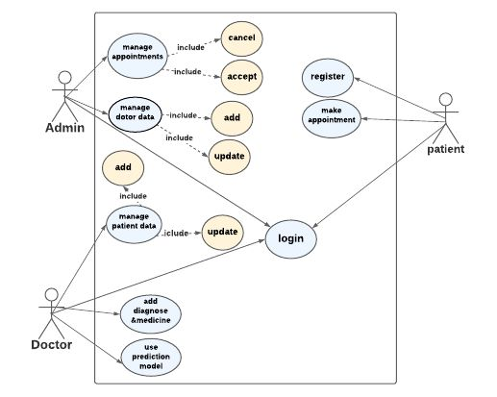

Figure 2\_1: use case diagram.

**Doctor** can login to the system, use the model to help him in his diagnose, view the appointments that with him, add medicine and diagnose to the patient and manage the data of patients. **Patient**: can login or register to the system and make appointment with doctor. **Admin:** can login and manage the appointments and doctors’ data.

## DFD Diagrams

**Data Flow Diagram:** showing the entities that interact with it (patient, doctor, admin, and treatment) and represent the flow of the data between the system and each external entity. It has many levels such as level 0, level 1 and level 2.

## Diagram Description automatically generated 2.3.2.1 DFD level 0 (Context Diagram)

Figure 2\_2: context diagram

**Context diagram:** patient can fill registration form, fill login form, and send appointment request and the system send it an appointment detail. Admin can fill login form, manage appointment, and manage the data of the doctor. Doctor can fill login form, request to view appointment, add patient record, use machine model, and update patient data with diagnose and medicine and the system send it an appointment list and result of machine model.

### 2.3.2.2 DFD Level 1

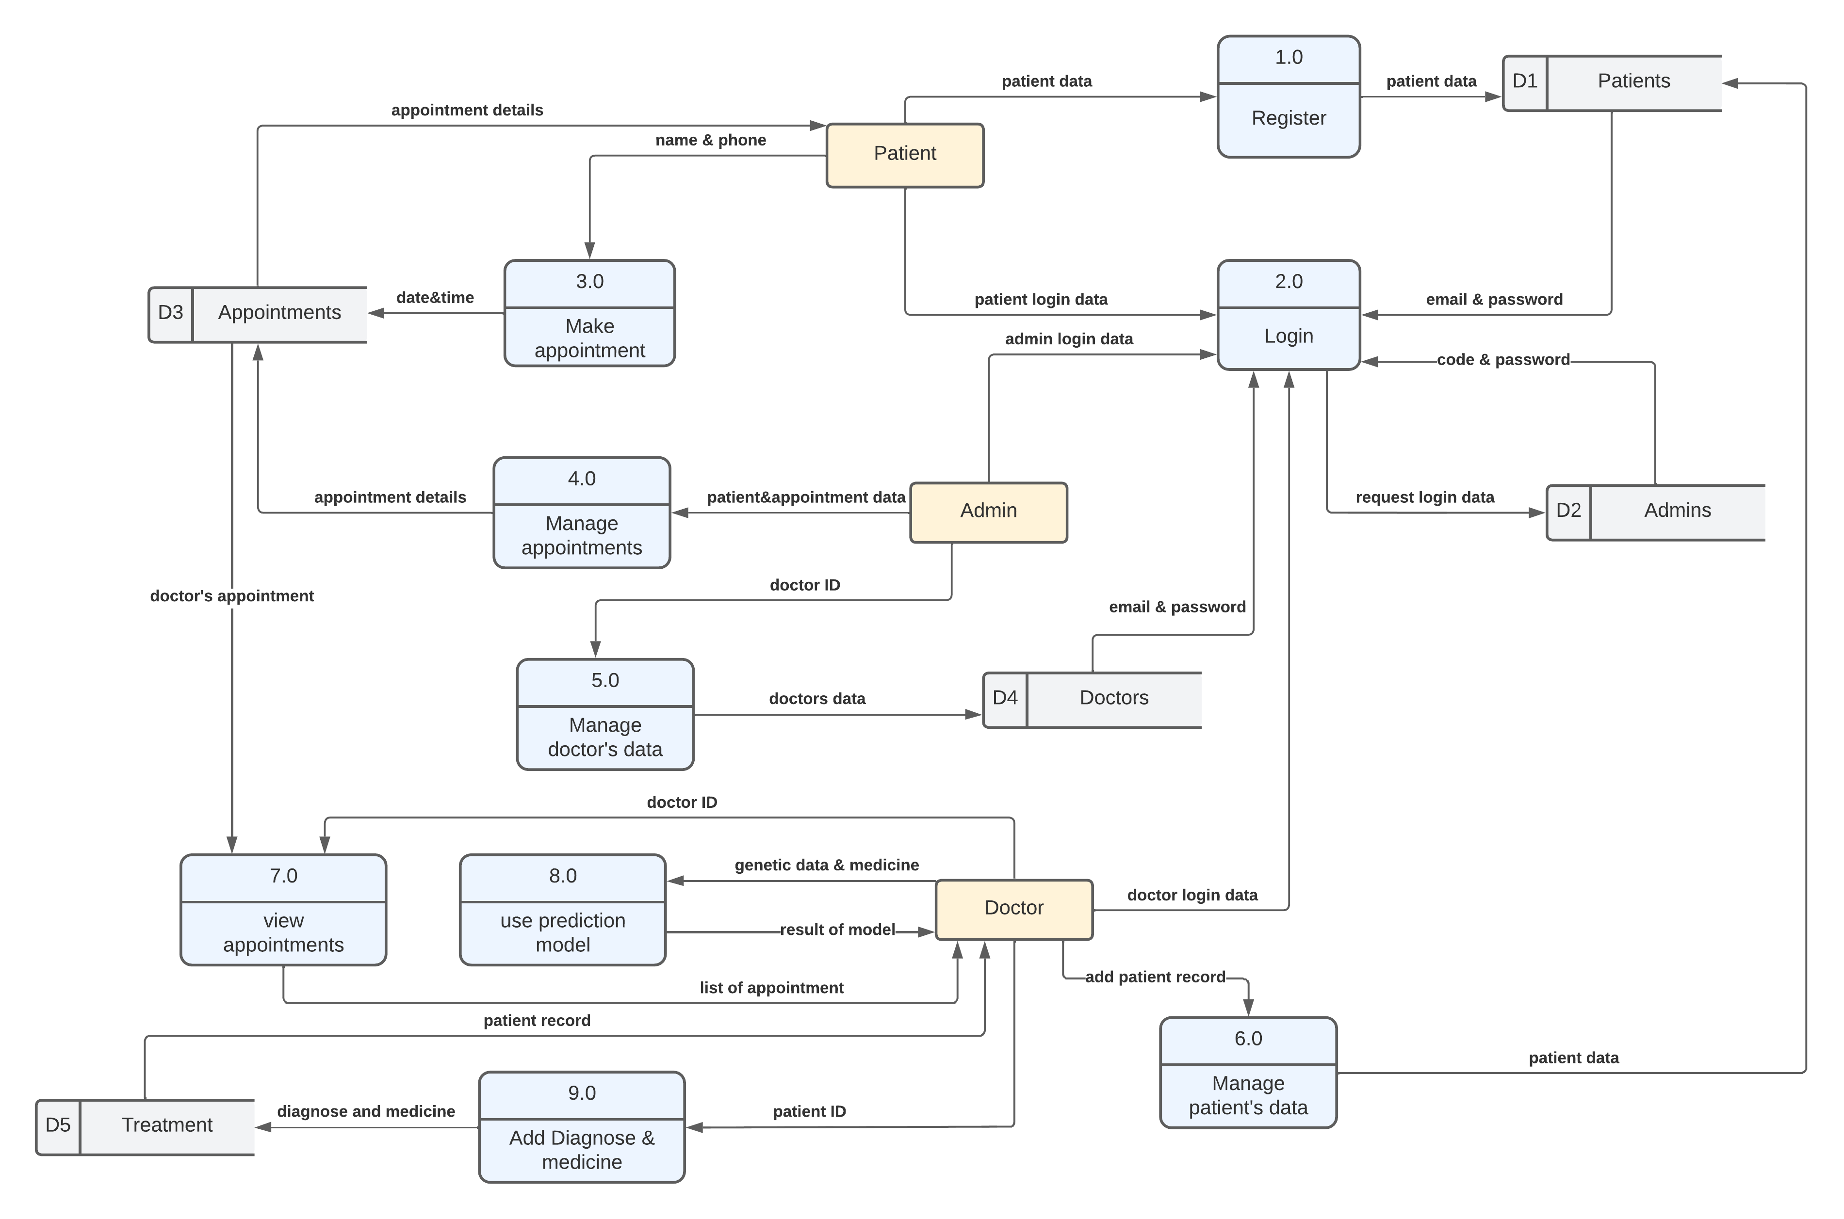

Figure 2\_3: DFD level 1

**DFD Level 1,** they go into more detail than a context diagram. The single process node from the context diagram is broken down into sub-process, which include data store such as(patient, admin, doctor, and appointments) that store the data, process such as (register, login, manage patient’s data, make appointment, manage appointment, manage doctor’s data, view appointments, use prediction model, and add diagnoses and medicine), external entity such as(patient, admin, doctor), who does the process and also include arrows which represent the flow of the data among external entity, process, and data store.

### 2.3.2.3 DFD Level 2

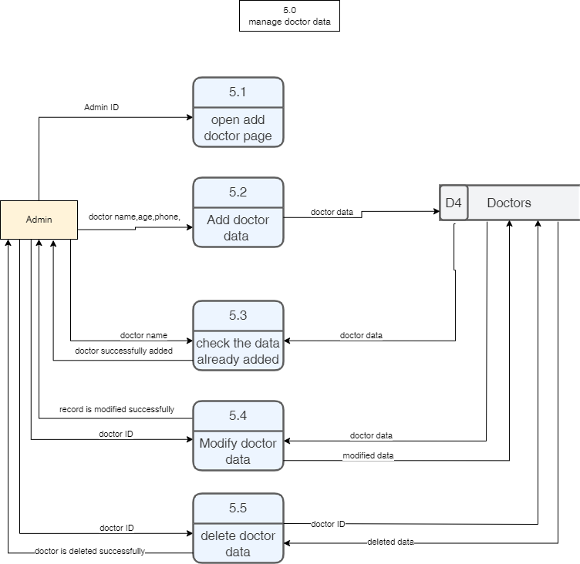

Figure 2\_4: DFD level 2

**DFD Level 2**, goes one step deeper into parts of 1-level DFD. Here, we choose the process number (5.0) named (manage doctor data) which show how the data of the doctor being managing by admin (external entity) and store data into data store (doctor) and use arrows to explain the flow of the data among external entity, process, and data store.

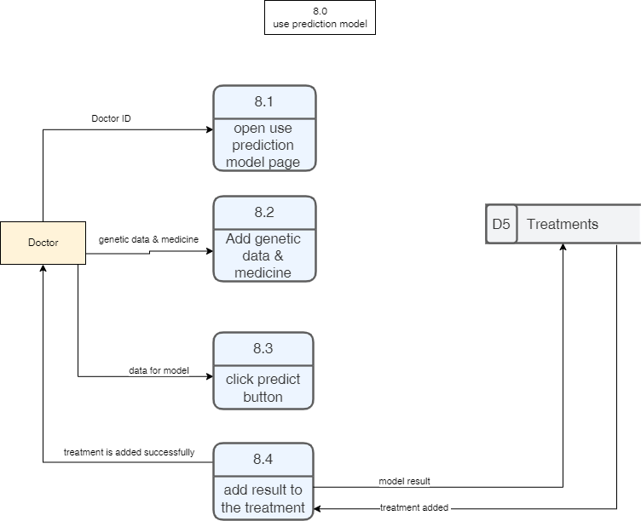

Figure 2\_5: DFD level 2

**DFD Level 2**, goes one step deeper into parts of 1-level DFD. Here, we choose the process number (8.0) named (use prediction model) which show the process to use the prediction model by doctor (external entity) and store data into data store (treatments) and use arrows to explain the flow of the data among external entity, process, and data store.

**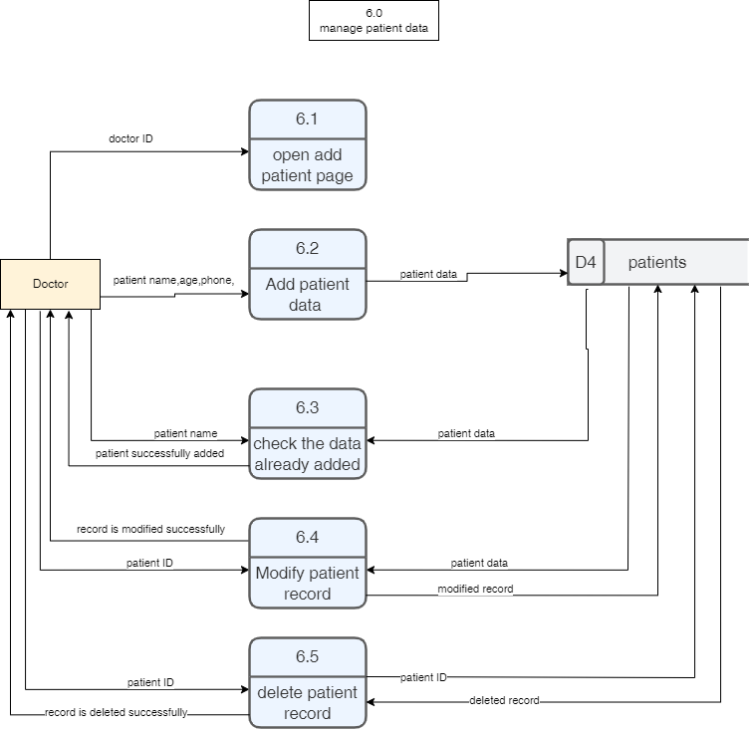**

Figure 2\_6: DFD level 2

**DFD Level 2**, goes one step deeper into parts of 1-level DFD. Here, we choose the process number (6.0) named (manage patient data) which show how the data of the patient being managed by doctor (external entity) and store data into data store (patients) .and use arrows to explain the flow of the data among external entity, process, and data store.

## 2.3.3 ACTIVITY DIAGRAM

## Diagram Description automatically generated2.3.3.1 Doctor

Figure 2\_7: Doctor’s Activity Diagram

**The activity diagram of the doctor**: explain to us what the doctor can do with the system. To login into the system: The system checks the login data if it is right or not. If the data is right then the doctor has access to his services as use the model to help him in his diagnose, view the appointments that with him, add medicine and diagnose to the patient and manage the data of patients. If the data is wrong, this means that this doctor isn’t added to the system so the admin will add him and then login.

## 2.3.3.2 Patient

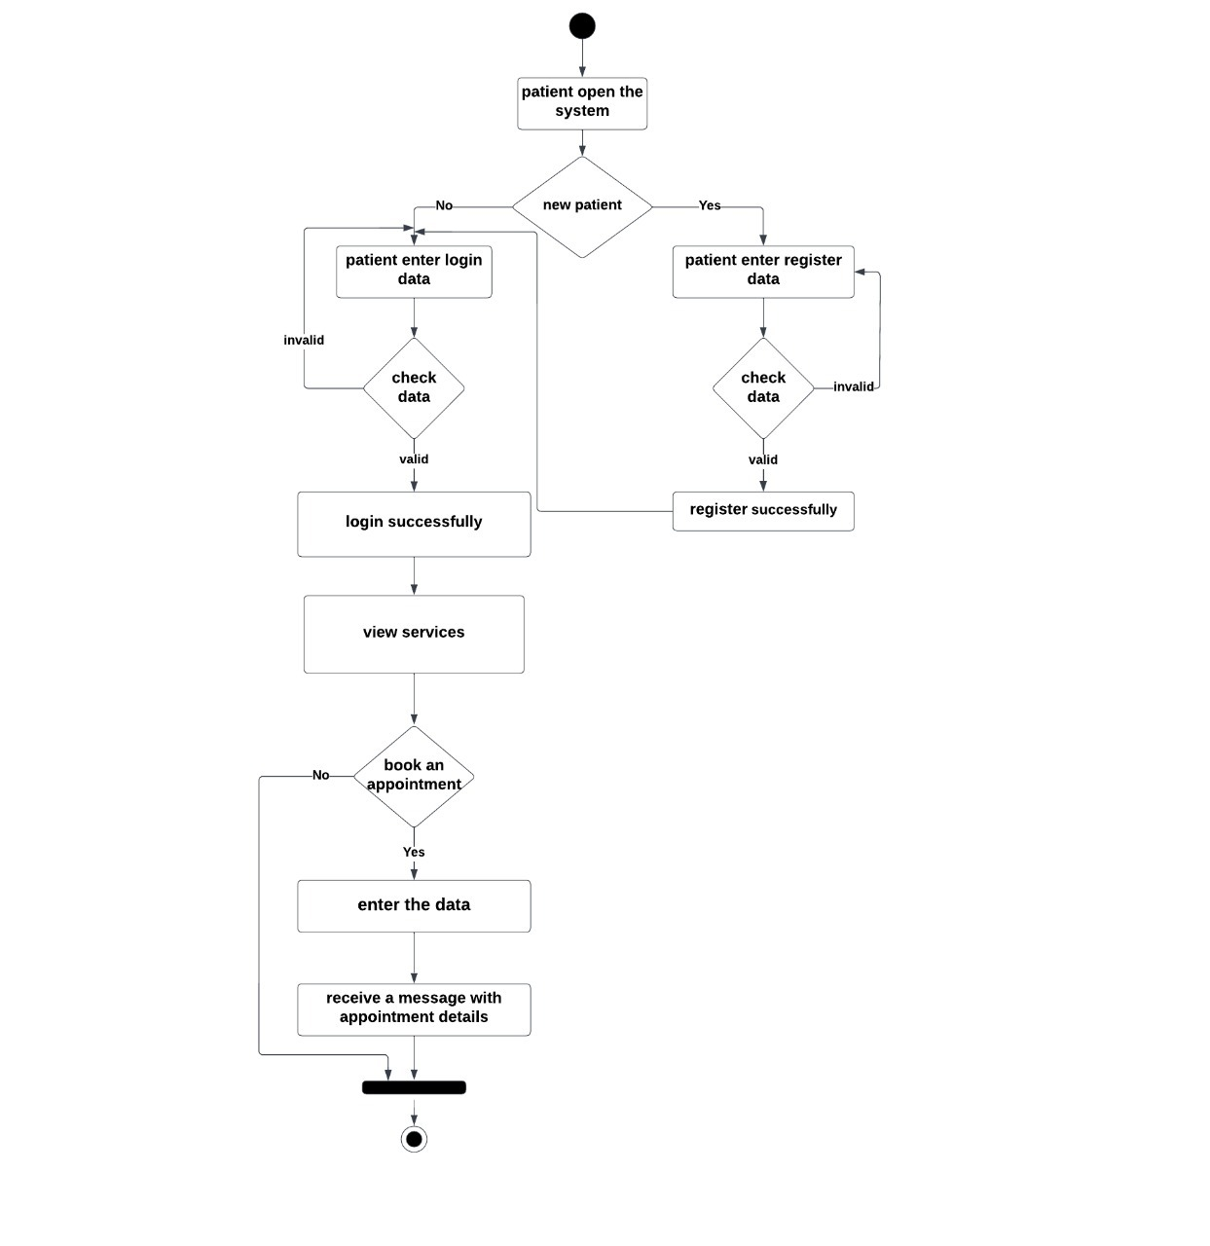

Figure 2\_8: patient’s Activity Diagram

**The activity diagram of the patient**: explain to us what the patient can do with the system. First patient must register to the app if it’s his first time to use the app. Then patient can login if he entered login data (email and password) correctly. After successful login, patient can view services (including Rays, Tests, and Clinics) and also patient can request to book an appointment.

## 2.3.4 Sequence Diagram

## 2.3.4.1 Patient

Figure 2\_9: Patient’s Sequence Diagram

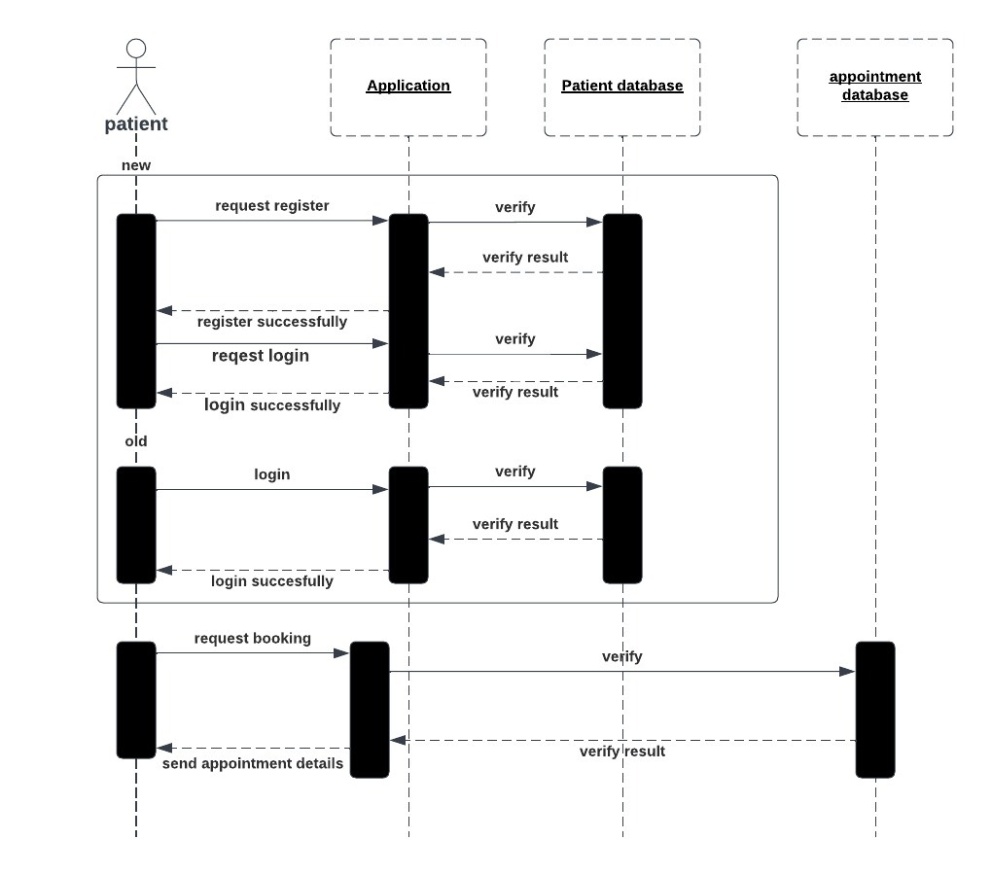

**Sequence diagram of the patient**: explain to us the steps that the system makes after the patient act with the system and what the messages that will appear to the patient in each case. As the patient enter the data then the system checks this data if it is correct then print to him login successfully and then let him book appointment then check the data in appointment if right send to him the details of appointment as date and name of doctor.

## 2.3.4.2 Doctor

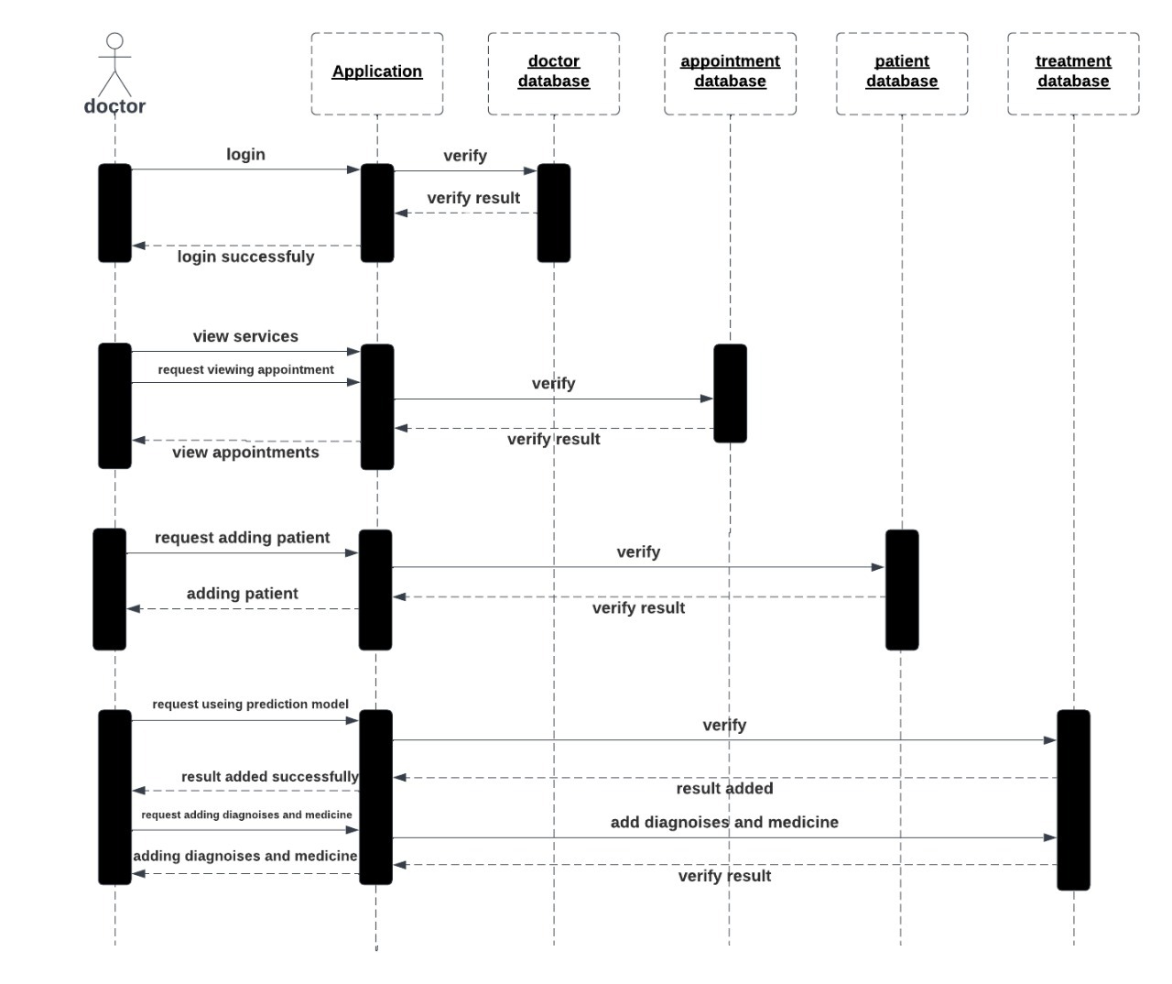

Figure 2\_10: Doctor’s Sequence Diagram

**Sequence diagram of the doctor**: explain to us the steps that the system makes after the patient act with the system and what the messages that will appear to the doctor in each case. As the doctor enter the data then the system checks this data if it is correct then print to him login successfully and then let him make his services as adding patient then check the data if it is right print to him the patient was added, predicting with model that the doctor enters the data then the data added to model then the result printed to the doctor.

## 2.3.5 ER Diagram

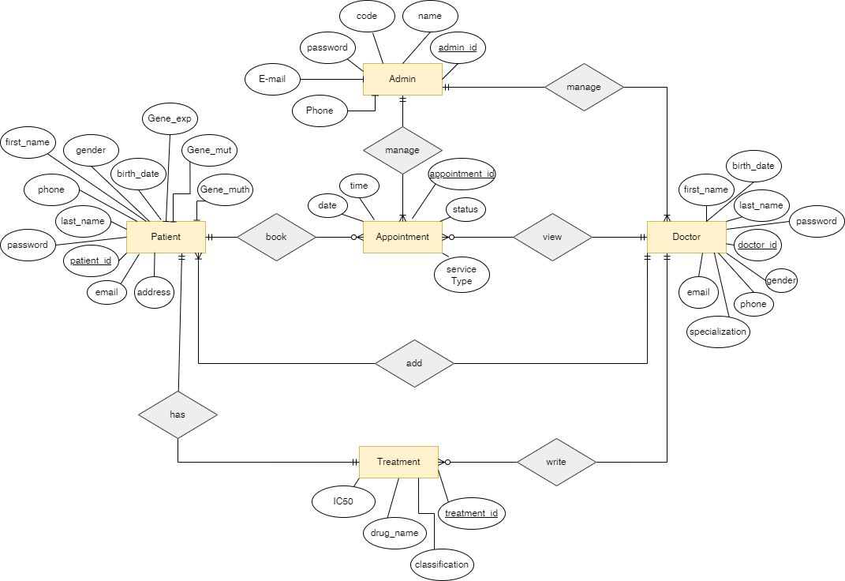

Figure 2\_11: ER Diagram

**Entity Relationship Diagram**: this diagram describes the relationships between entities in a database, such as persons, things, or concepts. Also, ERD describes the properties of these entities. In our system, main entities are (admin, patient, doctor, appointment, and treatment). Each of these entities has attributes such as (id, name, phone, age…. etc.) as shown in diagram.

## 2.3.6 mapping

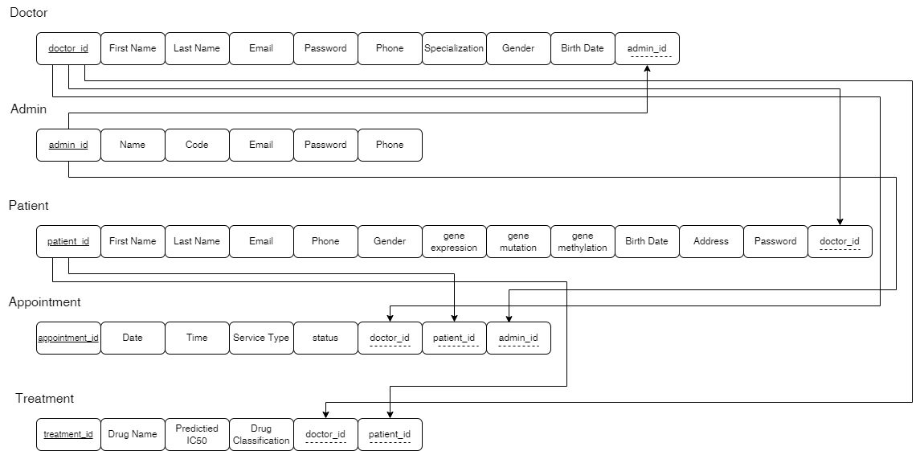

Figure 2\_12: Mapping

**Mapping:** this figure explains the relationship between tables in database, what are the primary key and from which primary key are foreign keys derived, in our system main entities are (admin, patient, doctor, appointment, and treatment), mapping explain the primary and foreign key of each entity as shown in figure.

## 2.3.7 Class Diagram

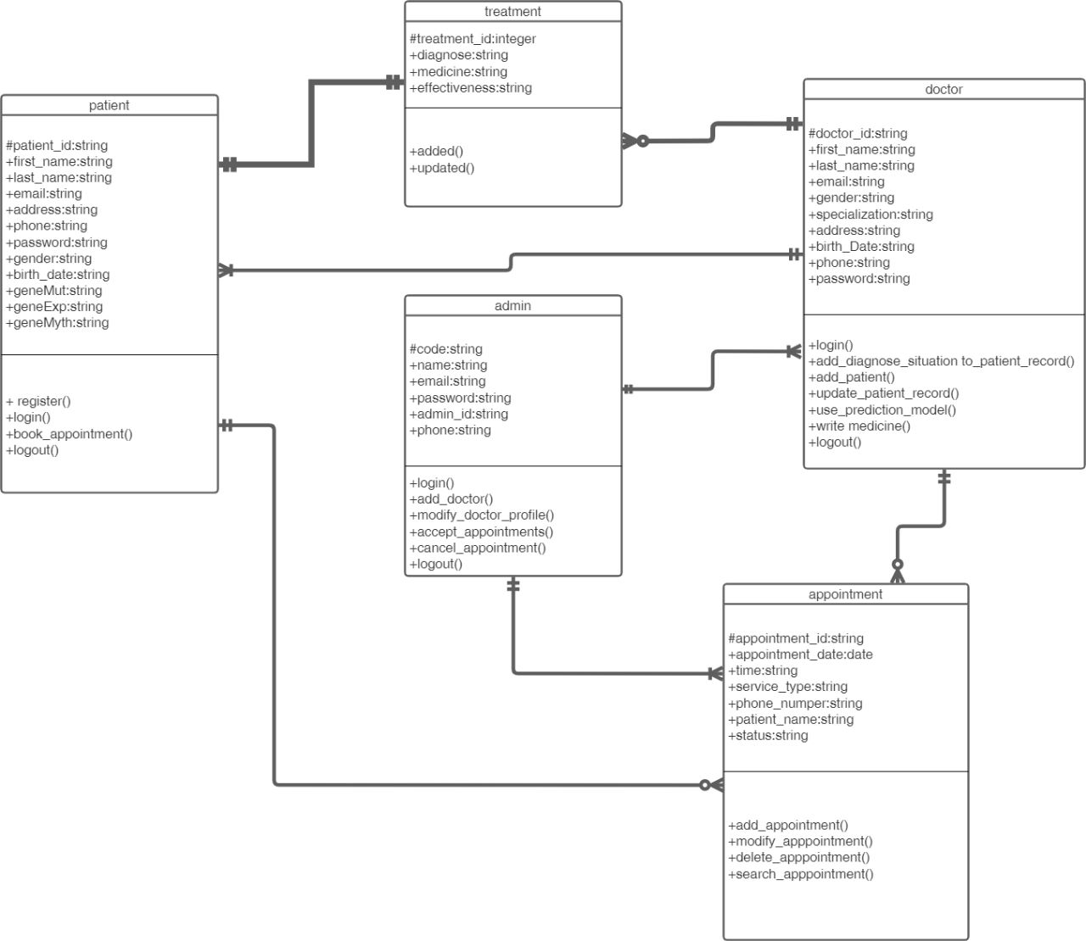

Figure 2\_13: Class Diagram

**Class Diagram**: this diagram shows the relationships between the objects and define what those objects perform and the services they offer. Class diagrams are important at various phases of system design because they display each user's properties and functions. The relations between entities may be one-one, many-many, one-many. Also, it describes the cardinality such as mandatory, optional.

-Relation between appointment and patient is one-many, meaning that each patient may have one or more appointment.

## 2.3.8 Database:

We use Firebase, it is a mobile and web application development platform, owned by Google. It provides a suite of services that developers can use to build and manage their applications, including:

Real time Database: A cloud-hosted NoSQL database that allows developers to store and sync data in real time.

Authentication: A service that allows developers to add user authentication to their applications, including support for social media logins and two-factor authentication.

Storage: A service that allows developers to store and serve user-generated content, such as images and videos.

Machine Learning: A service that allows developer to upload machine learning model and save it as .tf lite.

# 2.3.8.1: Authentaction

Authentication is the process of verifying the identity of a user or device. Firebase Authentication is a service provided by Firebase that allows authenticating users to app using various authentication methods, such as email and password authentication, phone number authentication.

Firebase Authentication provides several benefits, such as:

Security: Firebase Authentication provides secure and reliable authentication methods, and handles the complexity of securely storing and transmitting user credentials.

User management: Firebase Authentication provides tools for managing user accounts, such as creating new users, deleting users, and resetting passwords.

Integration: Firebase Authentication can be easily integrated with other Firebase services, such as Cloud Fire store, Cloud Functions, and Cloud Storage.

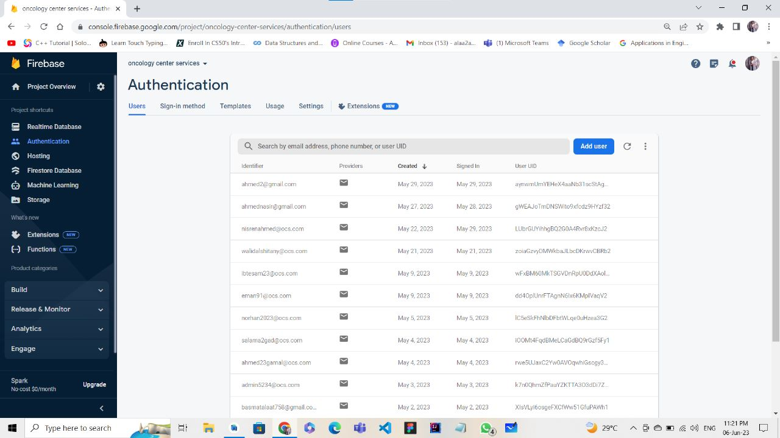

Figure 2\_14: Authentication.

When a user signs in to our app using Firebase Authentication, Firebase returns a unique user ID token that we can use to identify and authenticate the user in our app.

# 2.3.8.2 Realtime database:

It refers to the Real time Database service, which is a cloud-hosted NoSQL database that allows developers to store and sync data in real time. This means that any changes made to the database are immediately propagated to all connected clients, providing a seamless and responsive experience for users.

Firebase Real time Database uses a technique called data synchronization, which allows multiple clients to listen for changes to the same data and receive updates in real time. When a client makes a change to the database, Firebase synchronizes that change with other clients listening to that data. This allows all clients to have a consistent view of the data, regardless of where the changes originated.

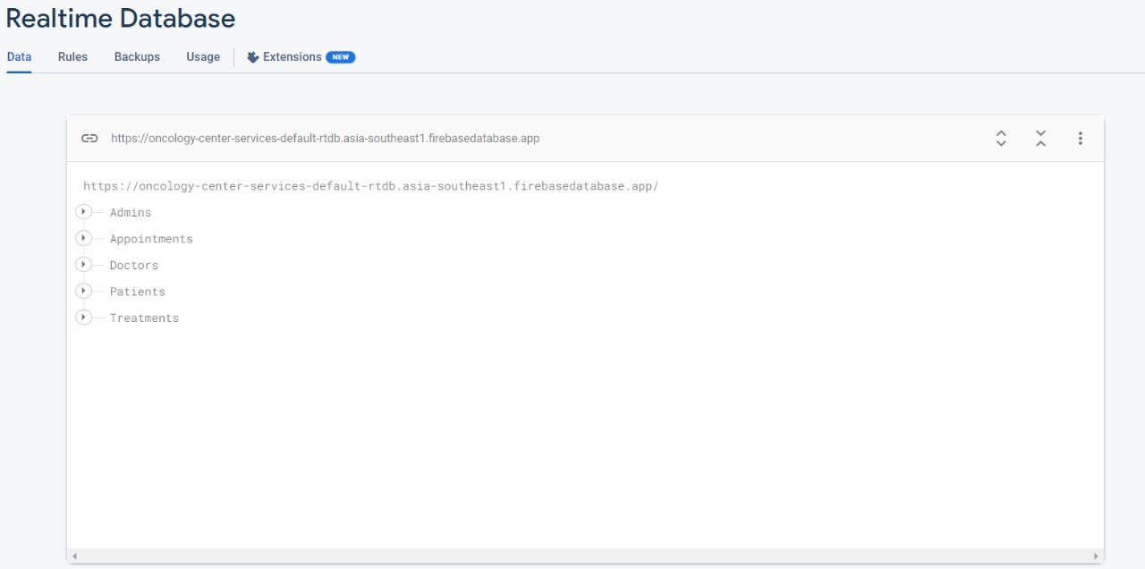

Figure 2\_15: real time database.

Our real time database contains data about Admins, Appointments, Doctors, Patients and Treatments. When click on each of them its data will appear.

##### 2.3.8.2.1 for doctors:

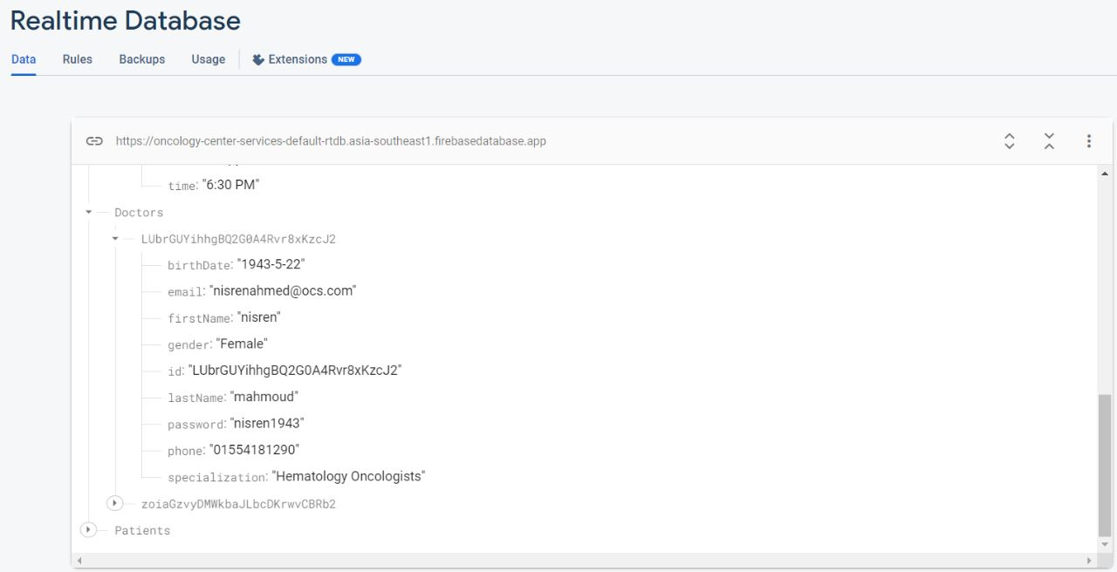

Figure 2\_16: real time database for doctors.

It contains the doctor’s ID, when we click on it, the doctor’s information will appear such as (birthdate, email, first Name, gender, id, last Name, password, phone, specialization).

##### 2.3.8.2.2: For admins

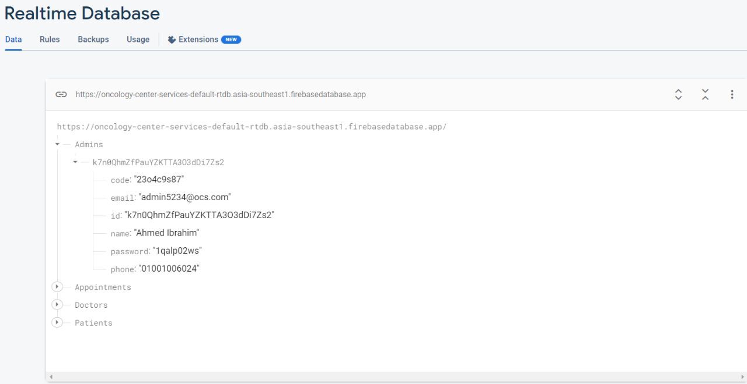

Figure 2\_17: real time database for admins.

It contains the admin’s ID, when we click on it, the admin’s information will appear such as (code, email, id, name, password, phone).

##### 2.3.8.2.3 For patients

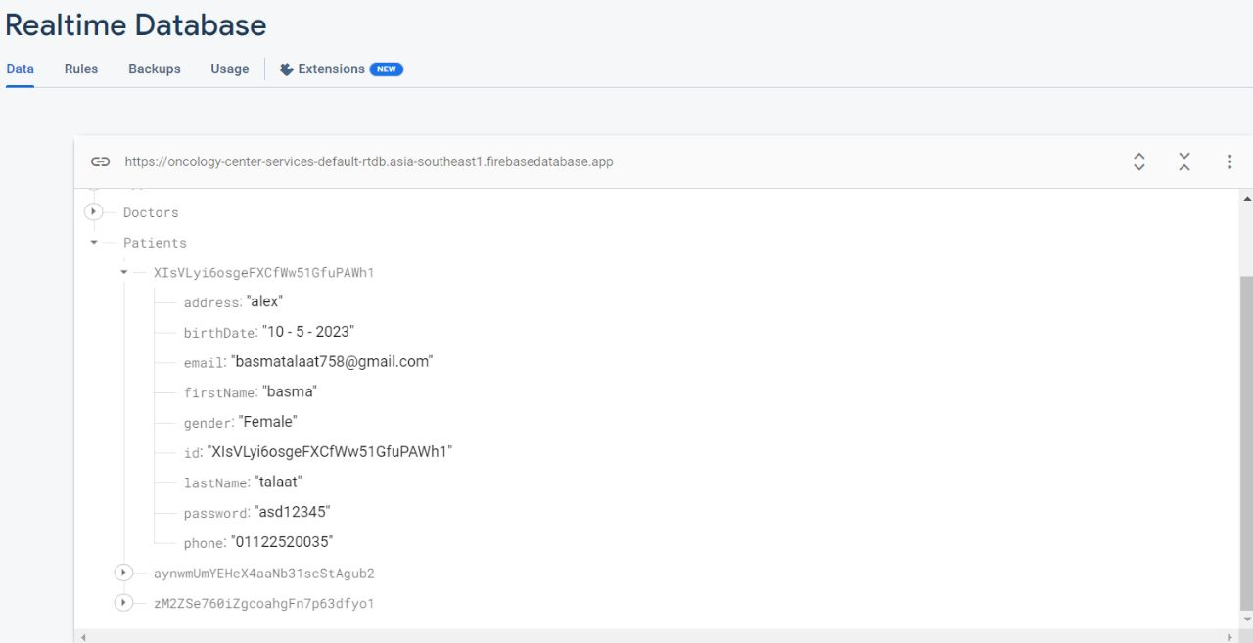

Figure 2\_18: real time database for patients.

It contains the patient’s ID, when we click on it, the patient’s information will appear such as (address, birthdate, email, first Name, gender, id, last Name, password, phone).

##### 2.3.8.2.4 for appointments

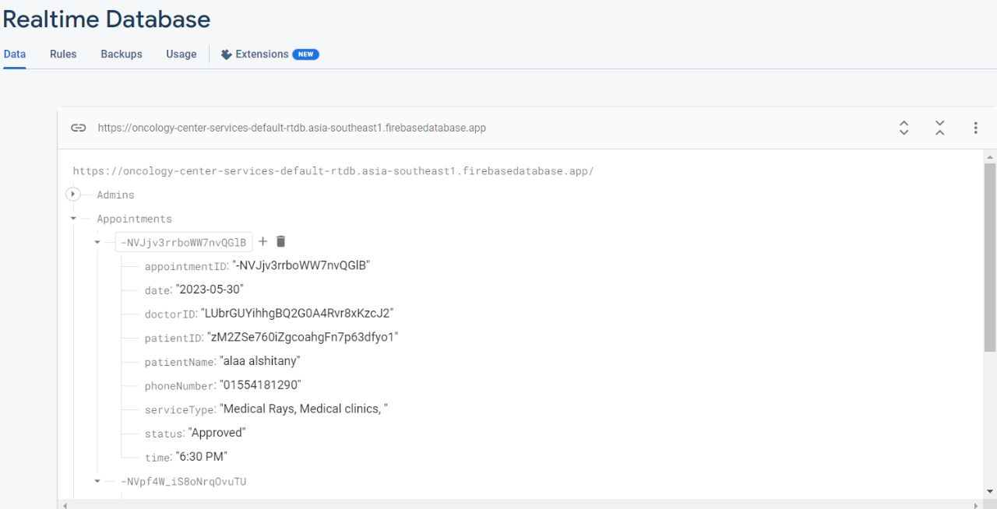

Figure 2\_19: real time database for patients.

It contains the appointment’s ID, when we click on it, the appointment’s information will appear such as (appointment ID, date, doctor ID, patient ID, patient Name, phone Number, service Type, status, time).

##### 2.3.8.2.5 for treatments

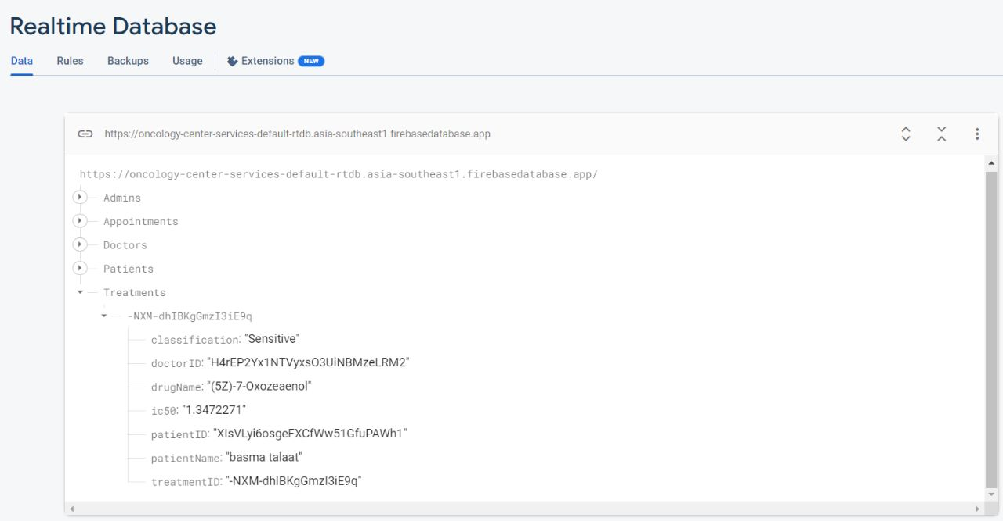

Figure 2\_20: real time database for patients.

It contains the treatment’s ID, when we click on it, the treatment’s information will appear such as (classification, Drug Name, doctor ID, patient ID, patient Name, ic50, treatment ID).

#### 2.3.8.3: Machine learning

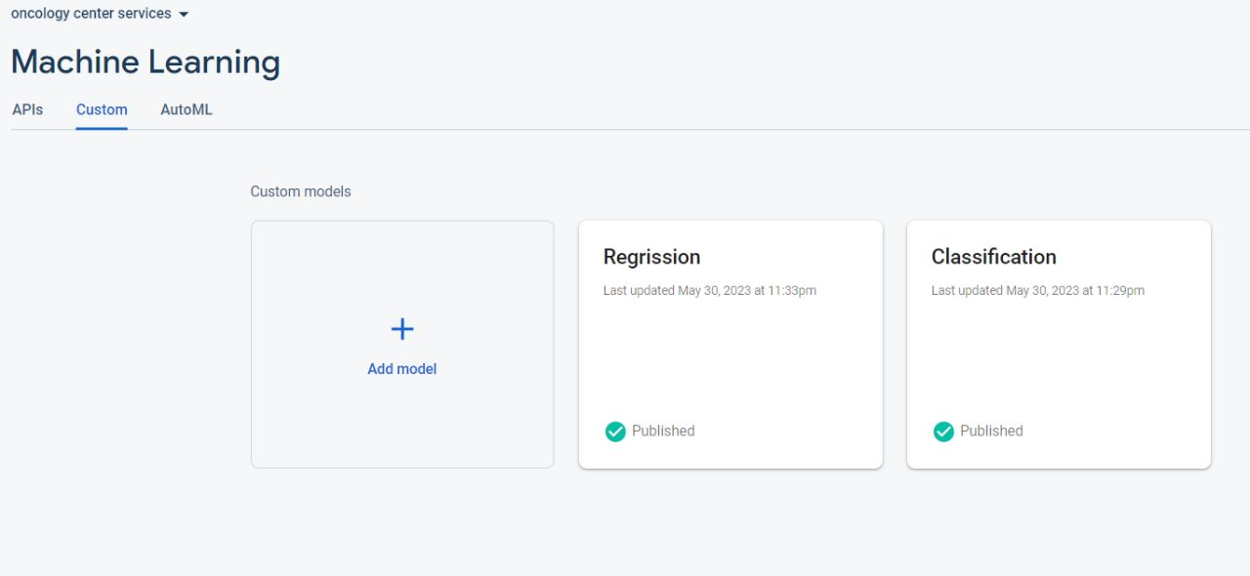

Figure 2\_21: Machine learning models.

Firebase enables upload machine learning models and save it as .tf lite , there are our two models(regression and classification).

#### 2.3.8.4 Storage

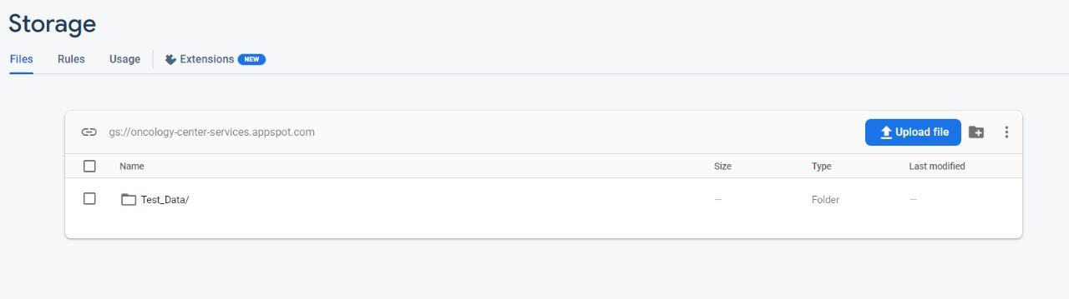

Figure 2\_22: stored data.

When open storage this path will appear, and when open this path the following page will appear.

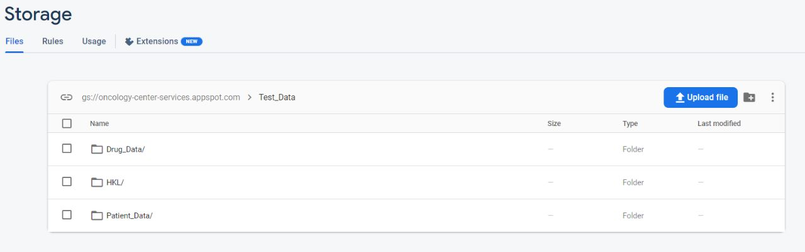

Figure 2\_23: stored data.

It contains data files which consists of drug’s files, HKL files and patient‘s files, we can upload or delete files.

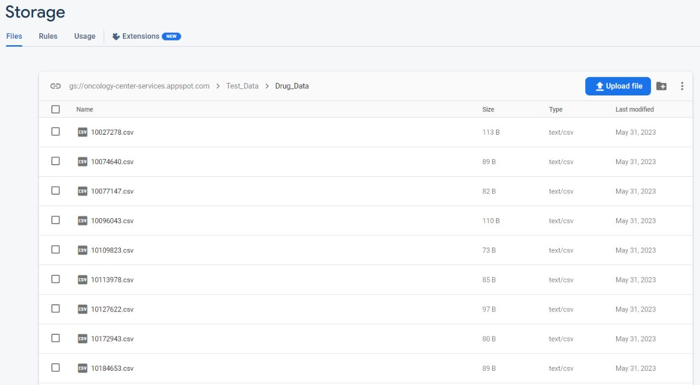

Figure 2\_24: drug files.

It contains drug files that each of them contain drugs information such as (ID, name, synonyms, targets, PubChem, sample size, count). We call these files during prediction.

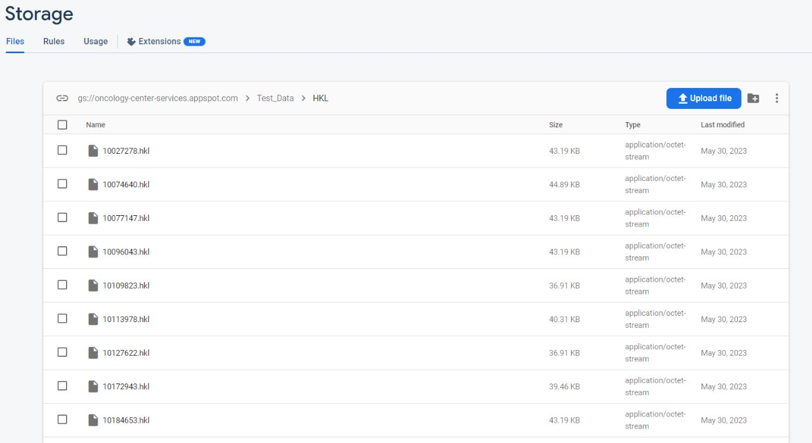

Figure 2\_25: HKL files.

It contains HKL files, the HKL file is an important tool for understanding the structure and function of proteins and for designing new drugs that target specific proteins.

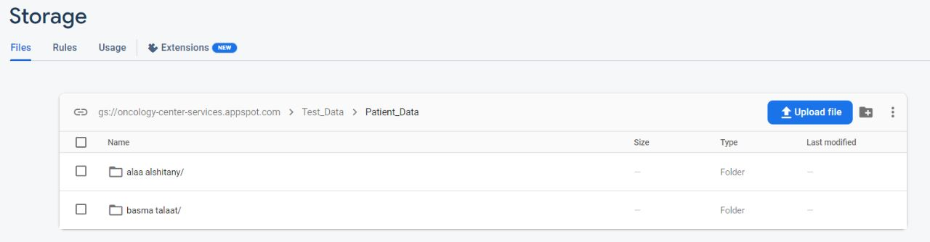

Figure 2\_26: Patient’s files.

It contains patient’s files (gene expression, gene mutation, gene methylation, we call these files during prediction.

Chapter Three

# Model

## 3.1 Data set

We have integrated 2 public databases in our study: **GDSC and CCL**. In our study, we operate on 256 genes and 238 drugs. **GDSC** database provide us: IC50 values for large-scale drug screening data, of which each IC50 value corresponds to a pair of cancer cell line and drug interaction.

**Half-maximal inhibitory concentration (IC50):** is the most widely used and informative measure of a drug's efficacy. It indicates how much drug is needed to inhibit a biological process by half, thus providing a measure of potency of an antagonist drug in pharmacological research .and when its value is small, it is evidence that the effectiveness of the drug is high.

**CCLE** database provide us: Genomic, transcriptomic and epigenomic data of more than a thousand cancer cell lines. For the three data omics, we focused on gene mutation data, gene expression data, and DNA methylation data.

1. 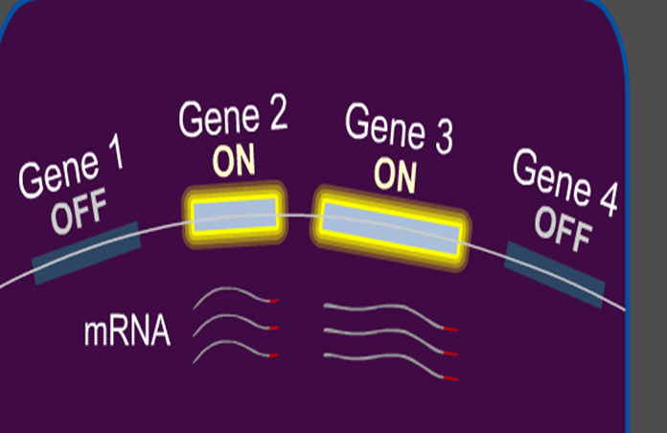**Genomic expression**: Gene expression is the process by which information from a gene is used in the synthesis of a functional gene product that enables it to produce end products, protein, or non-coding RNA. In other words: Gene expression is that process of turning on a specific gene to start making messenger RNA.

Figure 3\_1: Genomic expression

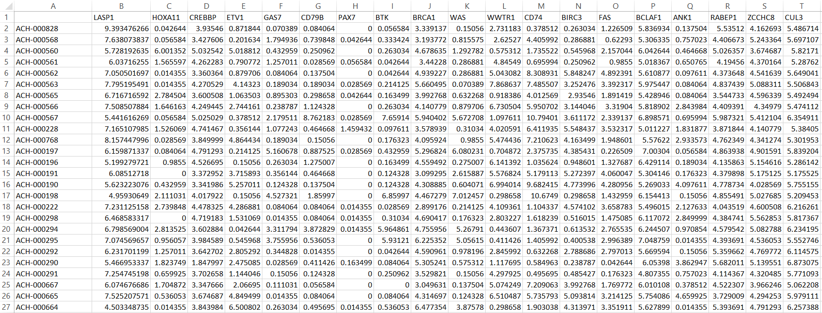

Figure 3\_2: Genomic expression dataset

1. **Genomic Mutation**: Genetic mutations are changes to your DNA sequence that happen during cell division when your cells make copies of themselves.

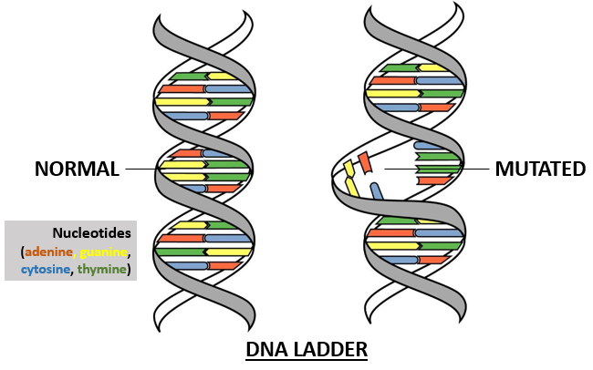

Figure 3\_3: Genomic Mutation

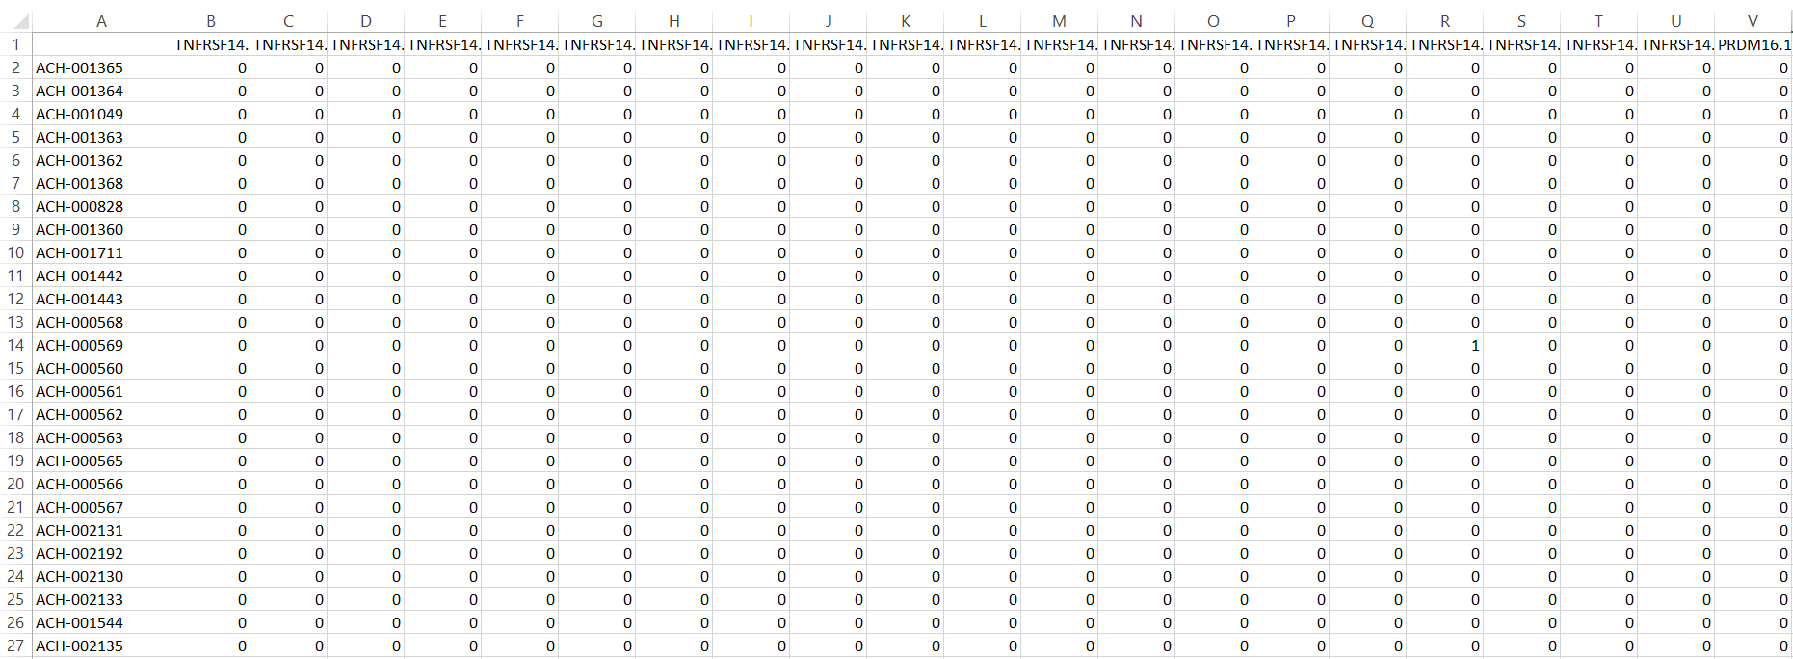

Figure 3\_4: Genomic Mutation dataset

1. **Genomic Methylation**: DNA methylation is a biological process by which methyl groups are added to the DNA molecule. Gene is inactivated by addition of methyl group to the DNA-cytosine forming methyl cytosine. Methyl cytosine combines with specific protein to form methyl cytosine protein complex which blocks transcription (stop copying).

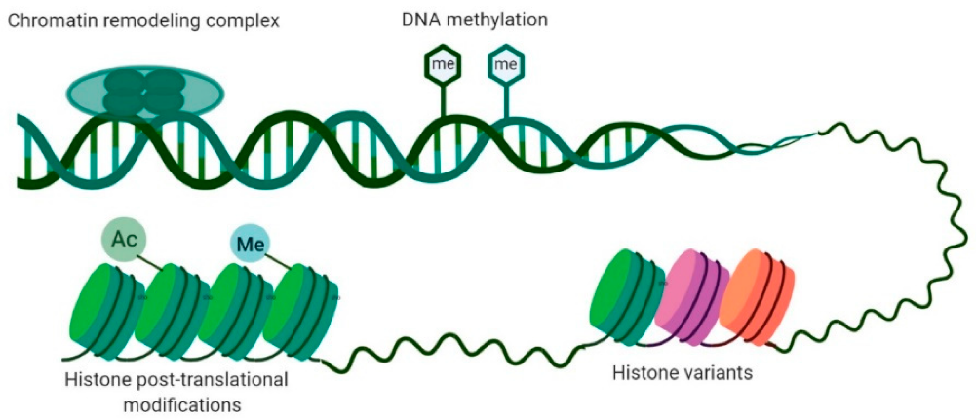

**Figure 3\_5: Genomic Methylation** Number

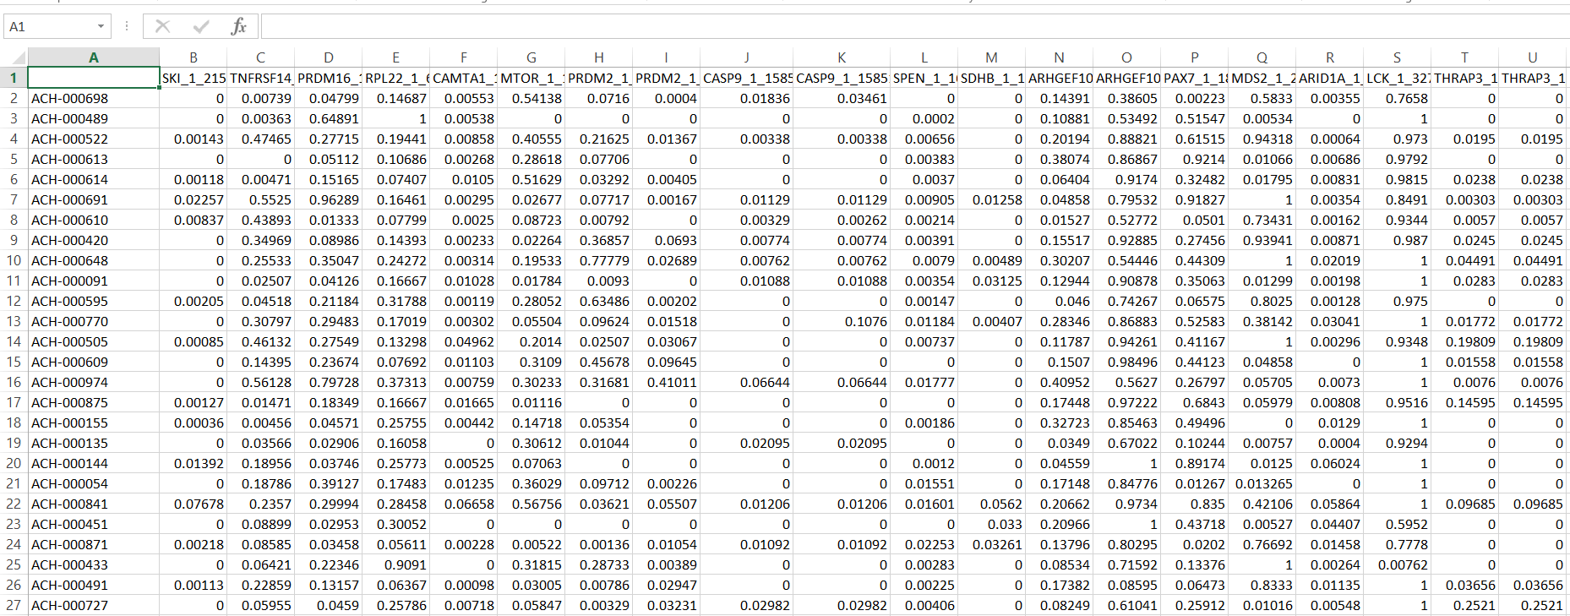

Figure 3\_6: Genomic methylation dataset

**GDSC** database:

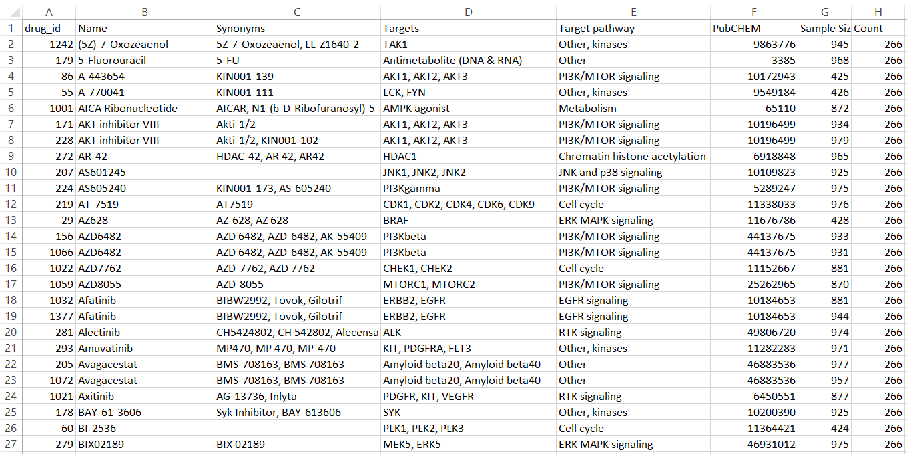

Figure 3\_7: Drugs dataset

## Model

The goal of the model is to determine if the drug is effective for the cancer patient or not depends on cancer cell profiles (genomic mutation, gene expression and DNA methylation data).

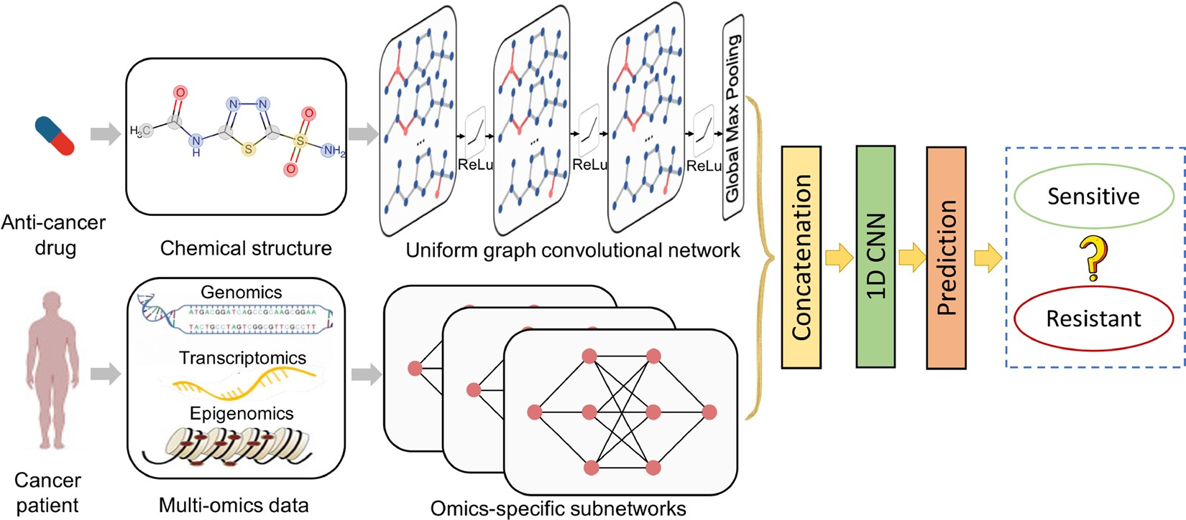

Figure 3\_8: Model Framework

The overview framework of model contains a UGCN and three subnetworks for processing drug structures and cancer cell profiles (genomic mutation, gene expression and DNA methylation data) respectively. Model takes a pair of drug and cancer cell profiles as inputs and predicts the drug sensitivity (⁠IC50, which denotes the effectiveness of a drug in inhibiting the growth of a specific cancer cell line.  ⁠) (regression) or claims the drug to be sensitive or resistant (classification).



Figure 3\_9: Model framework (first part)

**The first part: Drug**

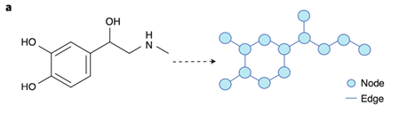Drug is represented as a graph based on the chemical structure.

Figure 3\_10: Drug Representation

## GCN

GCNs are a very powerful neural network architecture for machine learning on graphs. Graph convolutional network (GCN) is a neural network that operates on graphs. Given a graph G = (Nodes, Edges).

Learn the relationship between the molecular features of drugs such as (

**Chemical features**: These are molecular descriptors that capture the chemical properties of a drug, such as its size, shape, and functional groups. Chemical features can be represented as a matrix where each row corresponds to a drug and each column corresponds to a specific chemical feature.

**Structural features**: These are features that capture the structural properties of a drug, such as its substructures or its 3D structure. Structural features can be represented as a matrix where each row corresponds to a drug and each column corresponds to a specific structural feature.

**Pharmacological features**: These are features that capture the pharmacological properties of a drug, such as its target proteins or its side effects. Pharmacological features can be represented as a matrix where each row corresponds to a drug and each column corresponds to a specific pharmacological feature), and their neighboring molecules, The adjacency matrix of the graph is used to represents the connections between the nodes in a graph. The rows and columns of the matrix represent the nodes in the graph, and the elements of the matrix indicate whether there is an edge between two nodes. If there is an edge between two nodes, the corresponding element in the matrix is set to 1, otherwise it is set to 0.

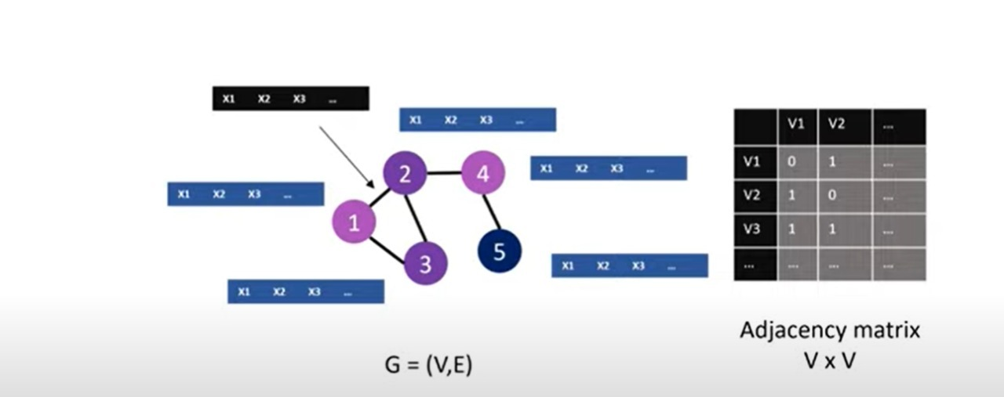

Figure 3\_11: GCN

**GCN Layers:**

**Input layer:** This layer receives the input graph data, which typically includes the node features and the adjacency matrix of the graph.

**Graph Convolutional Layer:** This layer performs the graph convolution operation on the molecular features of drugs, using the adjacency matrix of the drug

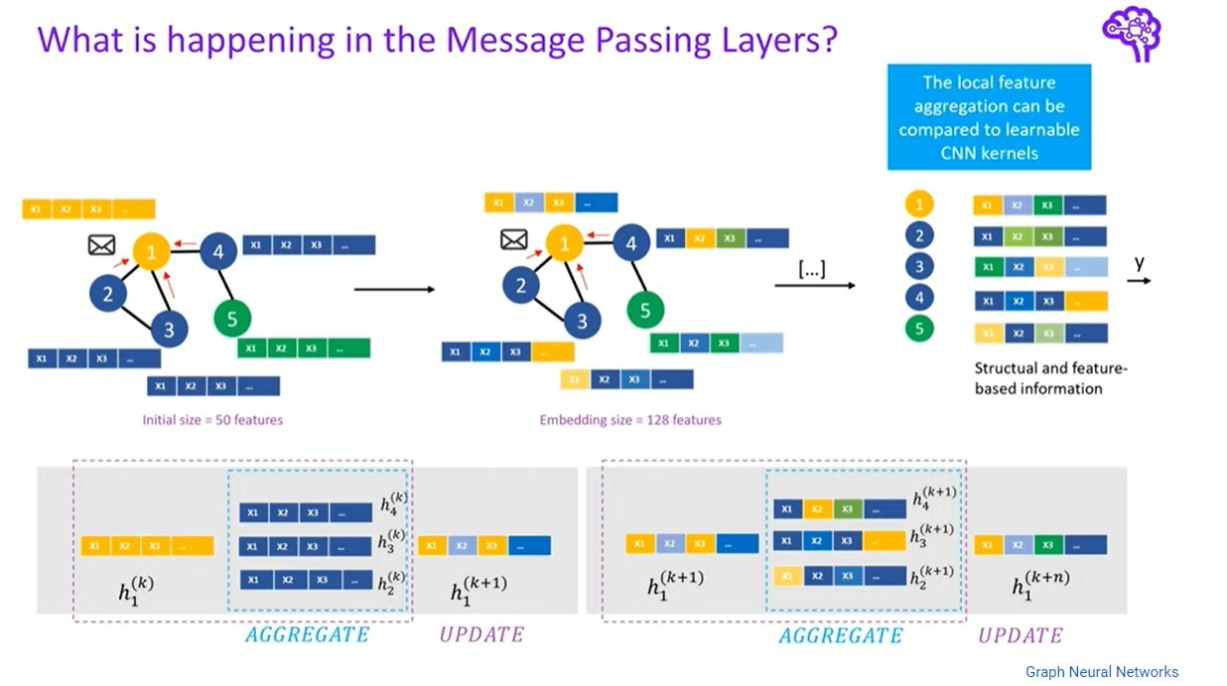

Figure 3\_12: Convolution

For each node, we get the feature information from all its neighbours. Each node takes messages from other nodes in more than round which leads to all nodes know each other.

**Graph convolution operation:**

1) Normalize the adjacency matrix of the graph by adding the identity matrix to ensure that the graph is fully connected, and then calculating the degree matrix of the normalized adjacency matrix.

2) Multiply the input feature matrix (i.e., molecular features of drugs) by the weight matrix to obtain a new feature matrix.

3) Compute the product of the normalized adjacency matrix and the new feature matrix to obtain the output feature matrix.

**Activation layer:** This layer applies an activation function to the output of the GraphConv layer

RELU: F(X) = MAX (0, X) returns the input value if it is positive, and returns 0 if the input value is negative.

**Batch Normalization layer**: This layer normalizes the output of the previous layer to improve the stability and performance of the model.

y = gamma \* (x - mean) / sqrt(variance + epsilon) + beta

where x is the input to the batch normalization layer, gamma and beta are learned scaling and shifting parameters, mean and variance are the mean and variance of the input batch, and epsilon is a small value added for numerical stability.

**Dropout layer:** This layer randomly drops out a portion of the output of the previous layer during training to prevent overfitting.

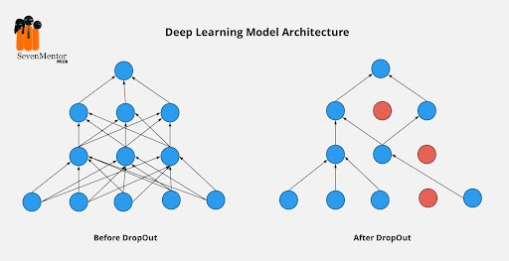

Figure 3\_13: Dropout

Randomly selects a subset of neurons in the network and sets their output to zero during training, effectively "dropping out" these neurons from the network for that particular iteration. This helps to prevent the network from relying too heavily on any one particular set of neurons, and encourages the network to learn more robust and generalizable features.

**Pooling Layer**: responsible for reduce the dimensionality of the feature matrix and improve the computational efficiency of the model by reducing the spatial size of the Convoluted Feature.

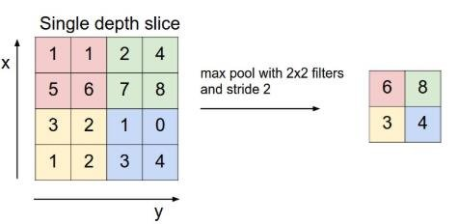

Figure 3\_14: Pooling Layer.

It involves dividing the input image into small non-overlapping rectangular regions, and taking the maximum value within each region to obtain a new output image with reduced spatial resolution.



Figure 3\_15: Model framework (second part)

**The second part:**

Each Omics data is represented by subnetwork and then integrated to one network.

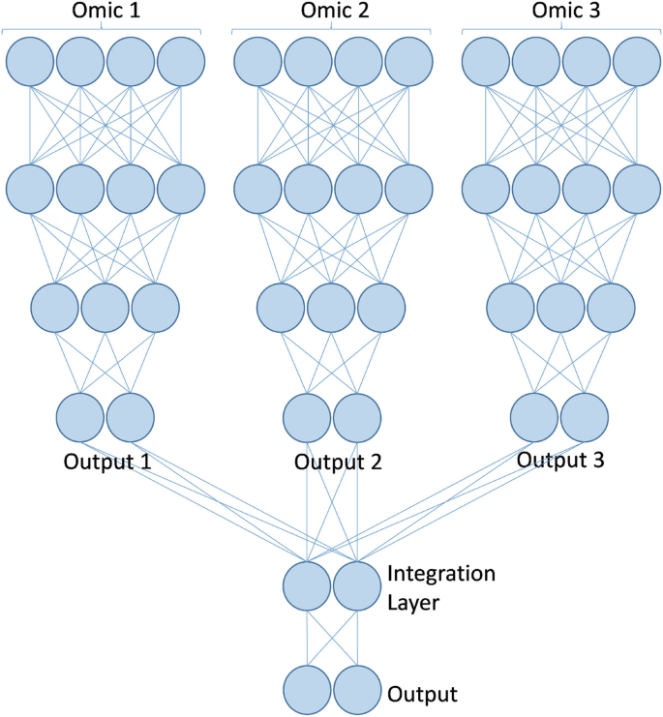

Figure 3\_16: Omics Representation

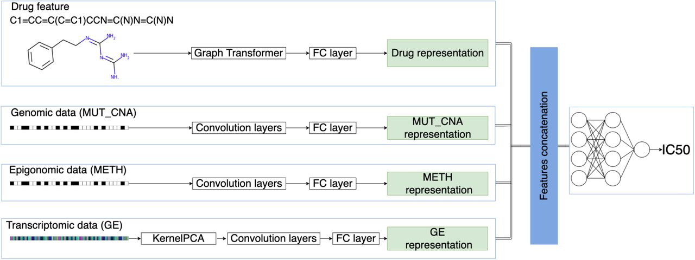Then concatenate the network (multi-omics-data) and graph (drug) and fed to CNN.

Figure 3\_17: Data Representation

3.4 **CNN**

A convolutional neural network (CNN) is a class of deep neural network most applied to analyze visual imagery.

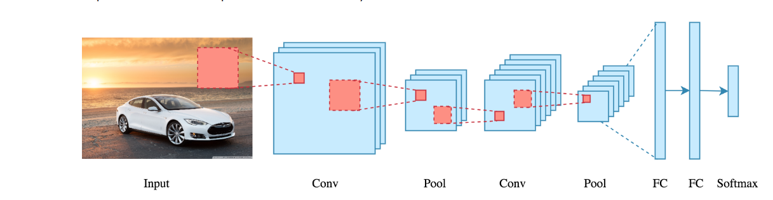

Figure 3\_18: CNN Layers

**Convolution layer**: convolutional neural network applies filter (kernel) to an input to create a feature map that summarize the presence of detected features in the input.

**Filter:** is a window that scans the image and enable CNNs to learn features from neighboring cells and take their value by training.

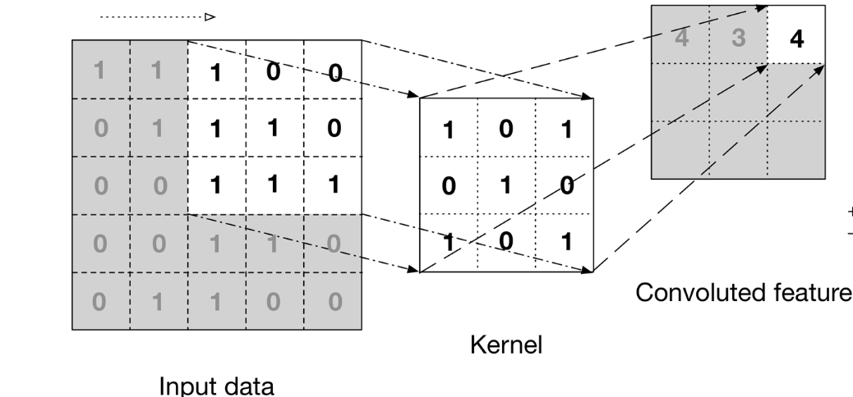

Figure 3\_19: Convolution layer

**Pooling Layer:** is responsible for reducing the spatial size of the Convolved Feature. This is to decrease the computational power required to process the data by reducing the dimensions. There are two types of pooling average pooling and max pooling.

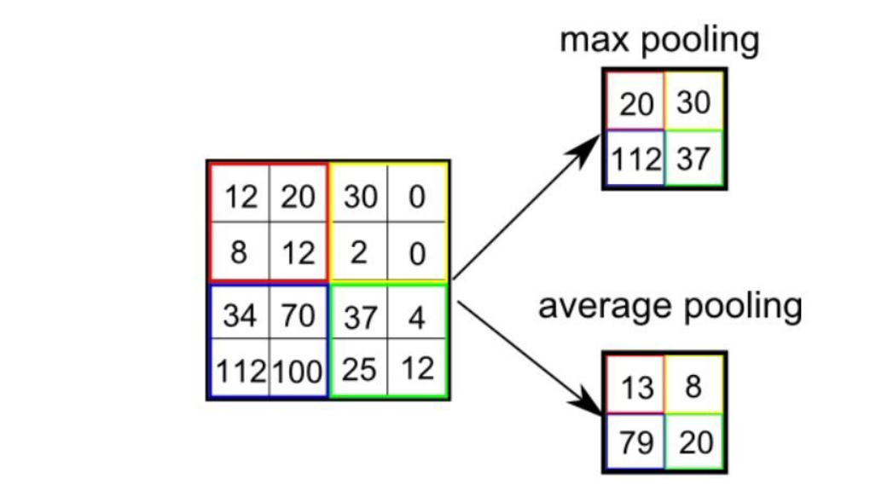

Figure 3\_20: Pooling layer

**FCI Layer:** The feature outputs will be flattened to column vector and feed-forward it to FCL, then this vector will be inputs for neural network.

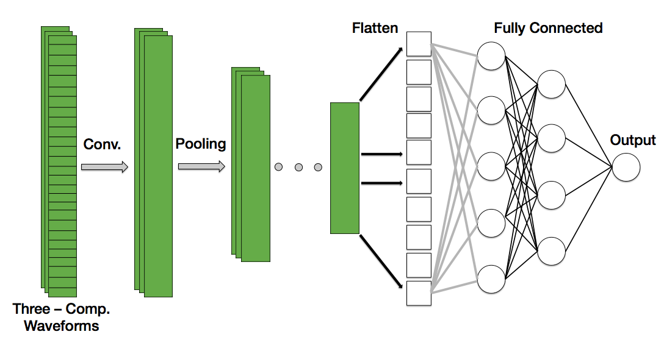

Figure 3\_21: FCI layer

Finally the output is either a regression value (the drug sensitivity (IC50) or a binary classification probability (sensitive or resistant).

Chapter Four

# Results

After we built the model, we made many changes and applied many methods to improve the Accuracy.

**First**: We used train-test split in the data splitting step of preprocessing and we obtained a result in classification: 0.8440, precision of regression: 0.9200. Then we used k-fold and found an increase in Accuracy classification: 1.0000, precision of regression: 0.9855.

**Second** : We changed the building of the model (GCN), so that **after the flatten layer**, we put machine learning model, as it turns out to us through searches that it gives a better result.

**With regression** we applied K\_Fold which gives us Pearson's correlation 0.9200, then we apply Linear Regression model with K\_Fold which gives us Pearson's correlation 0.9965, and Decision Tree model with K\_ Fold which give us

Pearson's correlation 0.9967.

|  |  |  |  |
| --- | --- | --- | --- |
| IDE | Run Time | Model | Person Correlation |
| Colab  pro | 25m | GCN(Train\_Test\_Split) | 0.9200 |
| Colab  pro | regression: 25m, | GCN(K\_Fold) | 0.9996 |
| Colab | 8.26 m | Linear\_regression(K\_Fold) | 0.9965 |
| Colab | 7.25 m | Decision\_Tree(K\_Fold) | 0.9967 |

**With Classification** model: GCN with Train\_Test \_Split gives us accuracy 0.8440, we apply K\_Fold With GCN which give us accuracy 1.0000, we also applied Random Forest model which gives us accuracy 0.8762 with train\_test\_split and 0.9996 with K\_Fold, and we applied Logistic Regression model which gives us accuracy 0.8361 with Train\_Test\_Split and 1.0000 with K\_Fold.

|  |  |  |  |
| --- | --- | --- | --- |
| **IDE** | **Run Time** | Model | **Accuracy** |
| Colab Pro | 20m | GCN(Train\_Test\_Split) | 0.8440 |
| Colab  Pro | 20m | GCN(K\_Fold) | 1.0000 |
| Colab | 12m | Random\_Forest with GCN  (Train\_Test\_Split) | 0.8762 |
| Colab | 14m | Random\_Forest with GCN  (Train\_Test\_Split) | 0.9996 |
| Colab | 9m | Logistic with GCN(Train \_Test Split) | 0.8361 |
| Colab | 8.30 m | Logistic with GCN(K\_Fold) | 1.0000 |

At the end, it became clear to us from the previous that when we used. -k-fold

We got the best result (Accuracy classification: 1.0000, Pearson’s correlation: 0.9996).

# Chapter 5

## 5.1 System Overview:

We design application to help solving some problems of patients, doctors and management**.** In our system we facilitate the process for patient, admin and doctor.

* **For patient**

He can make a registration or login if he had an email before, the system then open and the first page that patient will see is home page which contain our system services (medical rays, medical tests, medical clinics and booking an appointment)

And contain navigation bar that will help patient move between pages easily and services when he click on any of them, this will open other page which contain information about each services. System help patient to booking online which serve time. Patient can book through his name that register or login with also phone, and by choosing one service or more he need, when patient send request, the admin will send him a message contain time and date.

* **For admin**

Each admin will have a code and password to login with.

The system then open and the first page will appear is dashboard which help him navigate to pages and contain bar chart of doctor specializations and pie chart of requests. He will have a profile page contain his information, request page that contain requests made by patient and admin can accept them or canceled, doctor page which contain names of our doctors and when click on any of them will move to the page of doctor details and admin can update this information and in doctor page admin can add new doctor. In each page there is a navigation bar that will help him moving over pages.

* **For doctor**

Each doctor will have an email and password provided by the admin.

The system then open and the first page will appear is dashboard which help him navigate to pages. The doctor will have a profile page containing his information, appointments page that contain his appointments that the admin organized, patient page which contain patient names and when click on any then the patient details will appear and also he can add new patient, model page which uses to help him predict the suitable treatment containing upload files and predict, when choose upload files will open other page containing name of patient and labels to upload files such as gene expression file, genomic mutation file, methylation file (data of patient).when choosing predict will open the page of drug effectiveness containing patient name and drug and then click on predict button will show the result.

Patient, admin and doctor can log out from the system.

## 5.2 Introduction Pages:

. 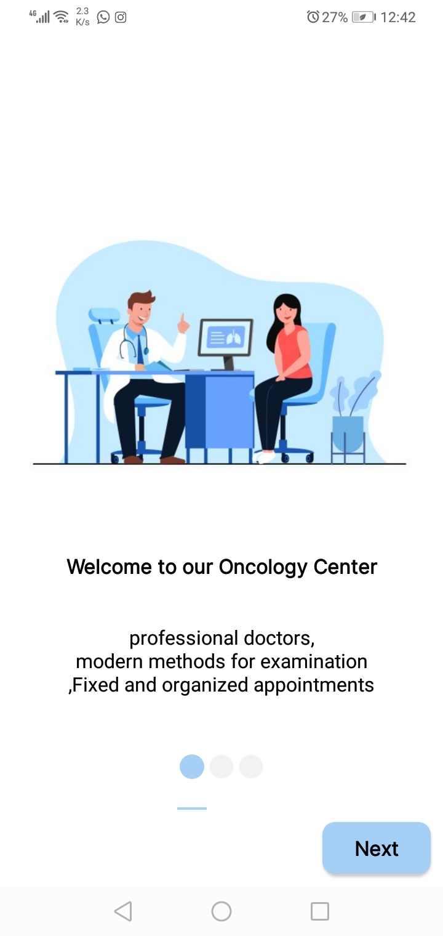

Figure 5\_1: Logo Figure 5\_2: Welcome Page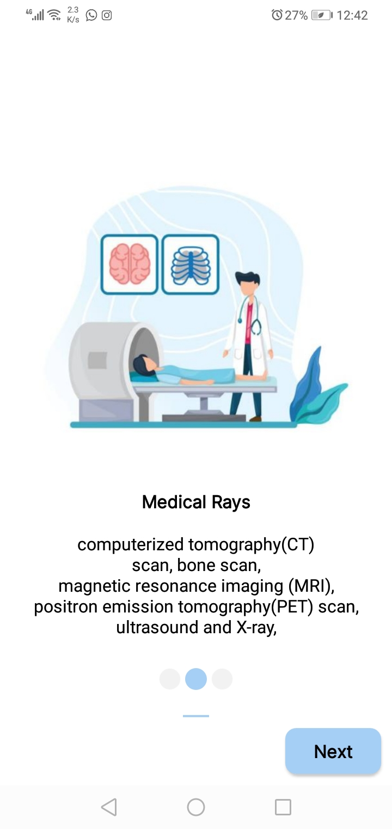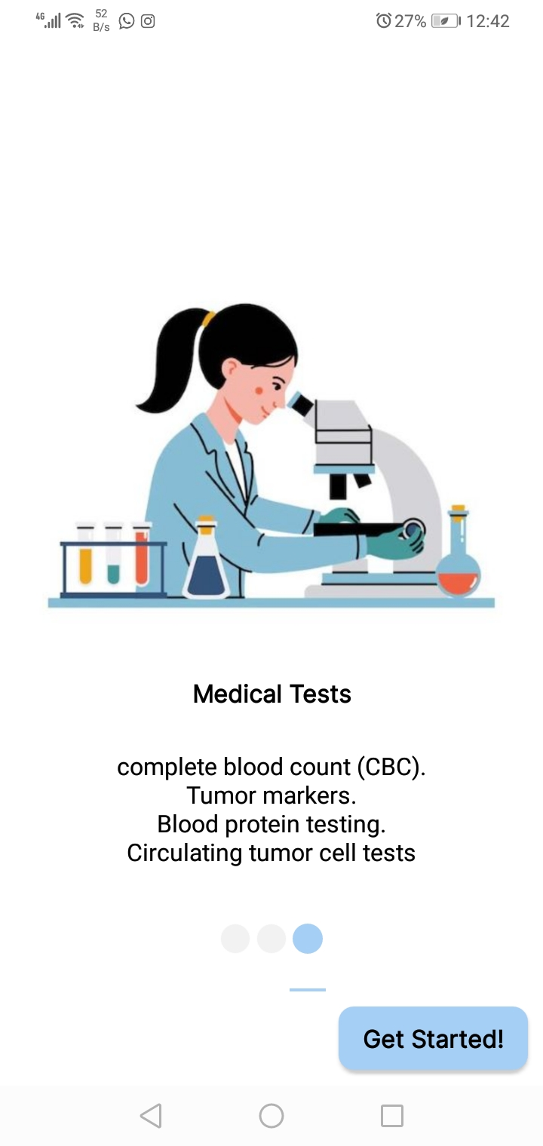

Figure 5\_3: Medical Rays Figure 5\_4: Medical Tests

These pages appear when user open application, it welcomes the user and explains some of the services in the system.

## 5.3 Admin pages

### 5.3.1 Login Page

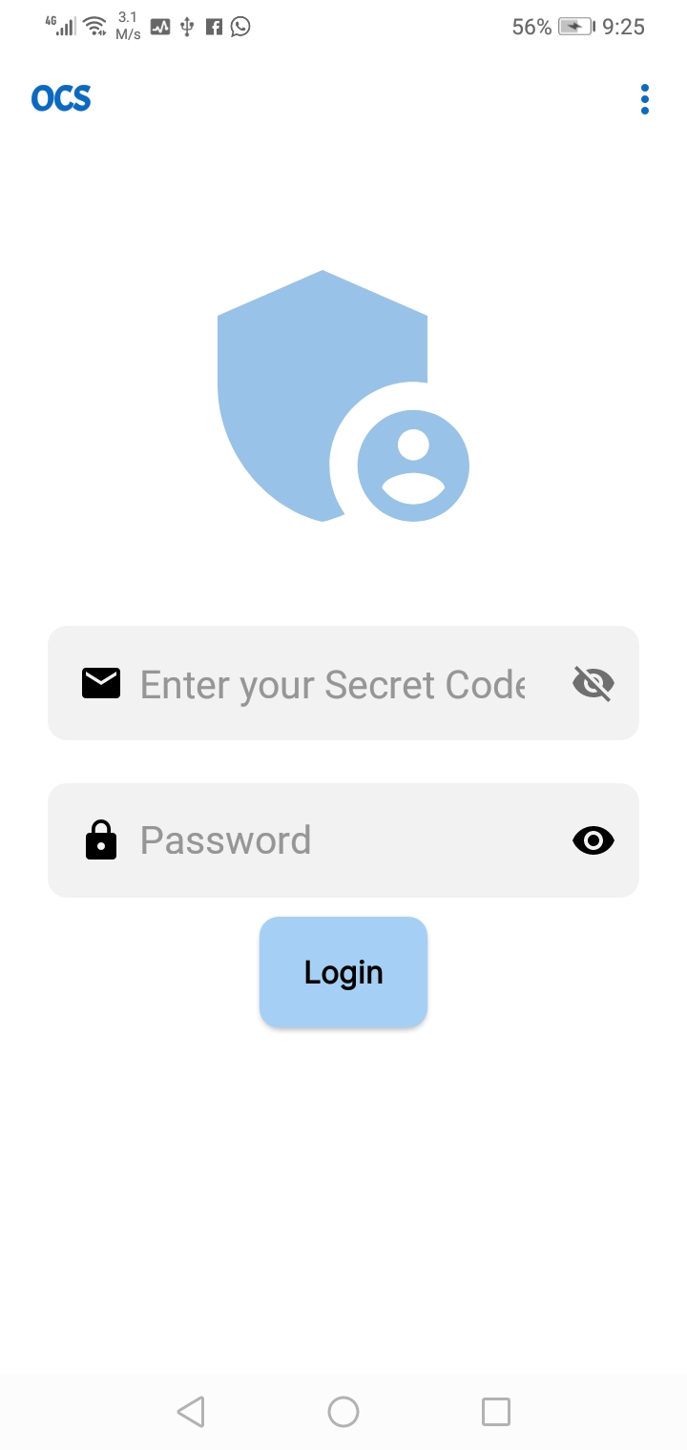

Figure 5\_5: Admin Login.

When admin open system, this page appears to him and he should enter his code and password to enter to system and perform his functions.

### 5.3.2 Dashboard

## C:\Users\dell\AppData\Local\Packages\5319275A.WhatsAppDesktop_cv1g1gvanyjgm\TempState\62D3ACF0E33805D5309154E95195FEA1\WhatsApp Image 2023-06-10 at 22.15.33.jpg

Figure 5\_5: Dashboard Page.

After admin login, this page appears to him and from here he can manage doctors and appointments, there are also chart illustrates approved and unapproved requests, and chart illustrates percentage of doctors at each department.

### 5.3.3 Navigation view

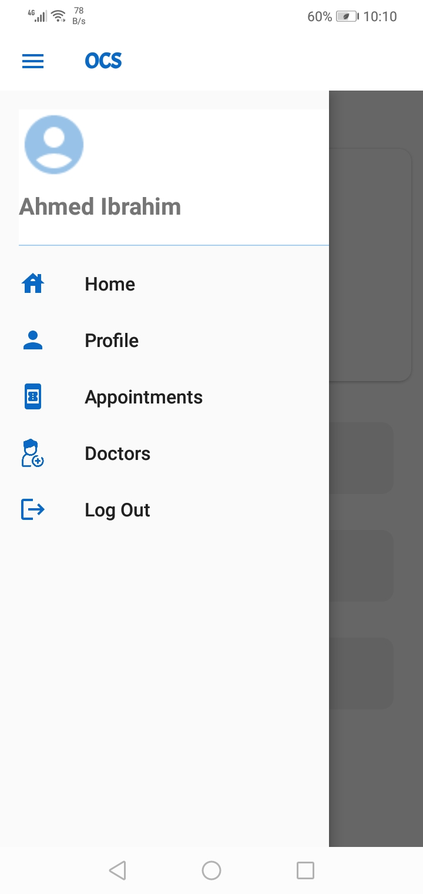

Figure 5\_6: Navigation View Page.

This page of navigation view, from this page admin can view his profile, appointments, doctors also he can log out.

### 5.3.4 Profile

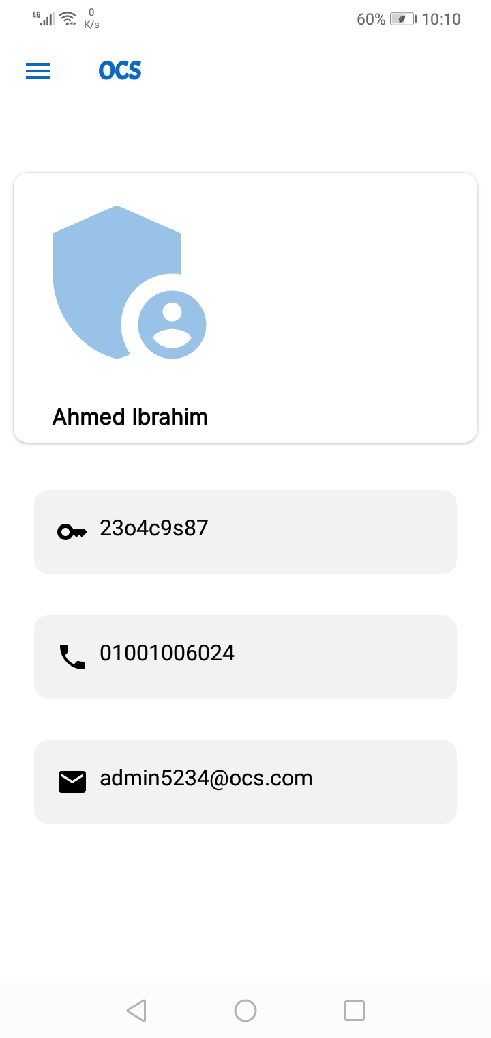

Figure 5\_7: Profile Page.

This page is profile of admin, appears when admin clicks on profile on navigation view contains his name, code, phone number and email.

### 5.3.5 Appointment requests

## C:\Users\dell\AppData\Local\Packages\5319275A.WhatsAppDesktop_cv1g1gvanyjgm\TempState\B5A043534C00C86A0C8487B42D4B3E29\WhatsApp Image 2023-06-10 at 22.16.56.jpg

Figure 5\_8: Requests Page.

This page appears when admin clicks on appointments on navigation, contains requests of system, admin can approve or unapproved them, when he clicks on false sign request is unapproved and when he clicks on right sign the new page will appears, from it admin choose time and date of each request, we will illustrate this page .

### 5.3.6 Appointment Confirmation

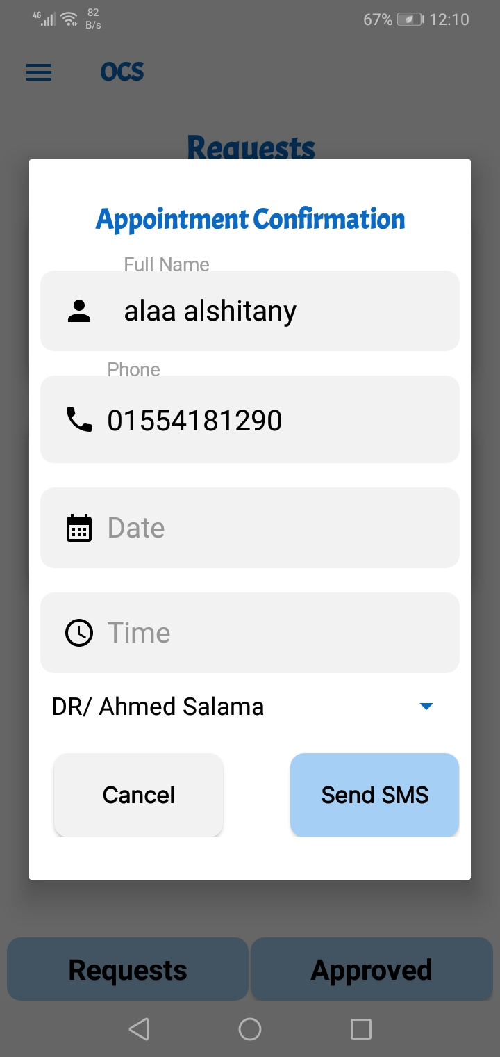 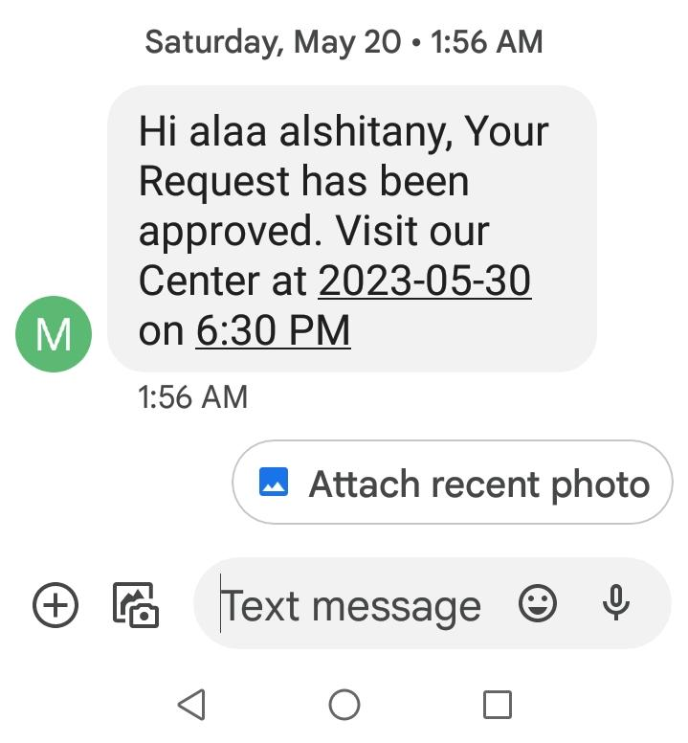

Figure 5\_8: Confirmation Page. Figure 5\_9: Confirmation message.

After admin approves request he should define time and date for each patient then sends message to his phone to confirm the booking. Figure 5\_9 illustrate the confirmation message sent to patient.

### 5.3.7 Approved requests

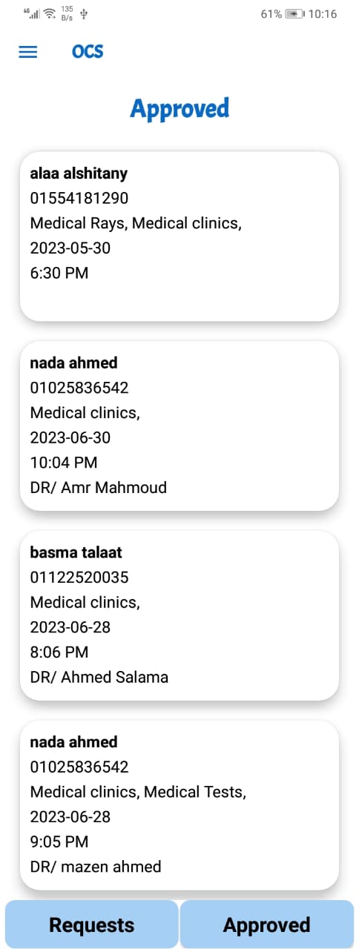

Figure 5\_10: Approved Requests Page.

This page contain approved requests which contain patient name, phone number, service type, date, time and doctor name.

### 5.3.8 Doctors

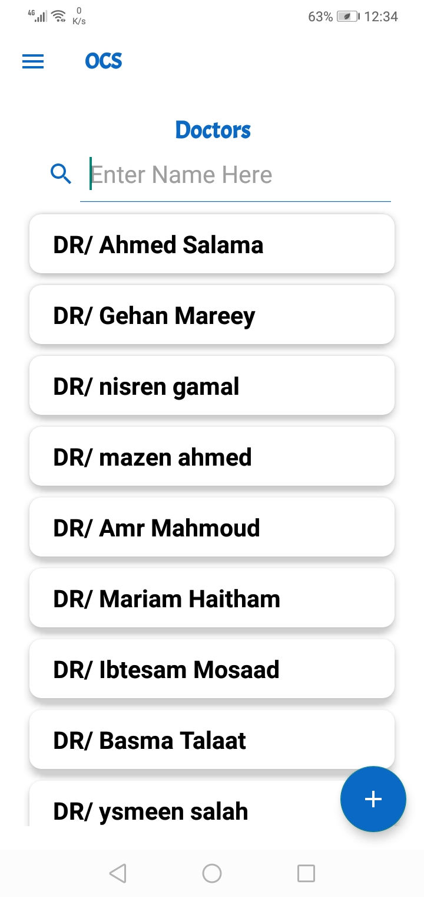 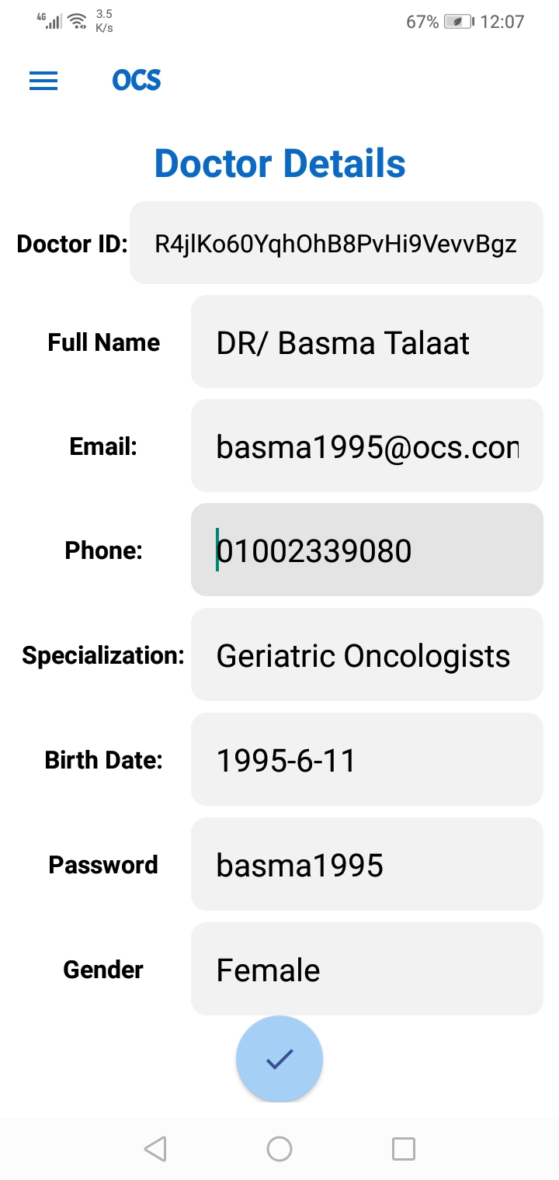

Figure 5\_11: Doctors page. Figure 5\_12: Doctors details page.

Figure 5\_11 contains doctors name, when click on doctor name, figure 5\_12 will appears which contains (doctor ID, full name, email, phone, specialization, birth date, password and gender), admin can adds new doctor by clicking on plus sign.

### 5.3.9 add Doctors

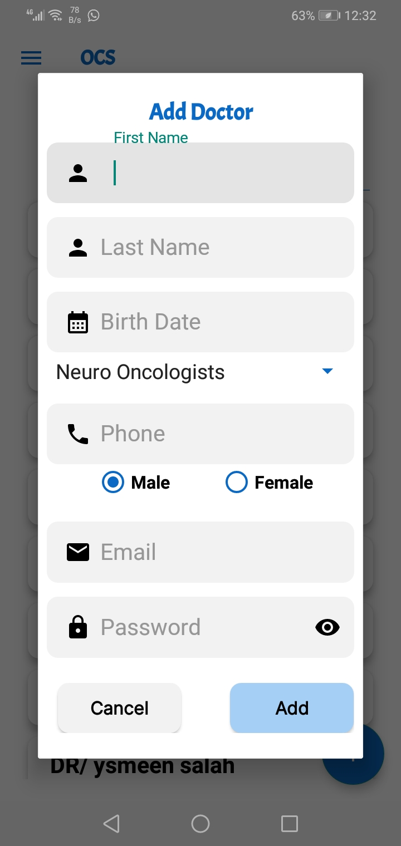

Figure 5\_13: Add Doctors page.

**This page appears when admin clicks on plus sign, from this page admin can add new doctors by adding information of doctor (name, birth date, specialization, phone, gender, email and password), by clicking on Add new doctor is added successfully.**

## 5.4 Patient pages

### 5.4.1Register Pages:

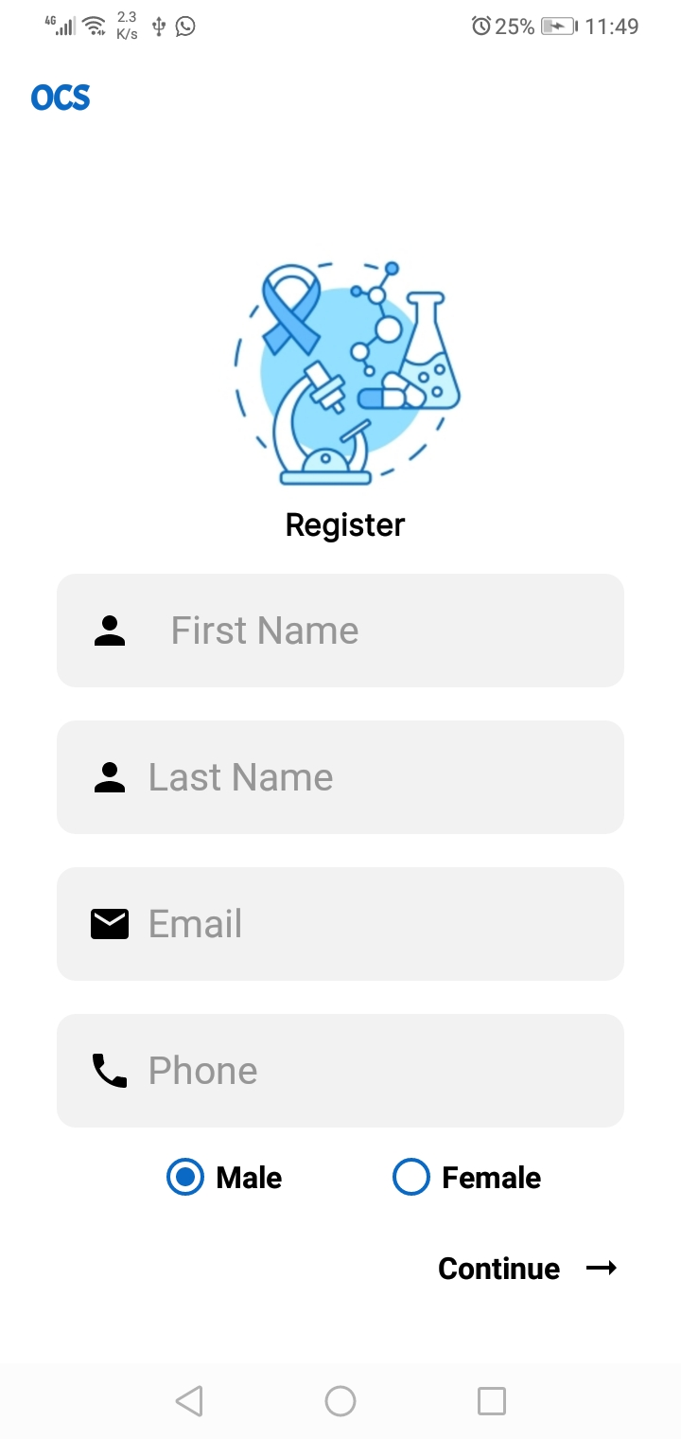 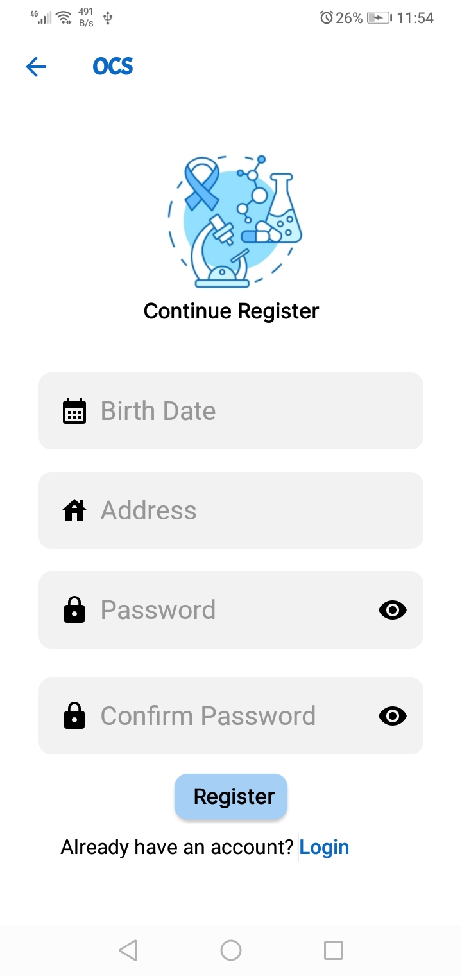

Figure 5\_14: Register Page 1. Figure 5\_15: Register Page2.

When patient use an application for the first time he should sign up (register) by entering his information such as (First Name, Last Name, Email, Phone, Birth Date, Address, Password, Confirm Password),when patient click on register his data will be saved in storage in firebase and he can login easily.

### 5.4.2 Login Page

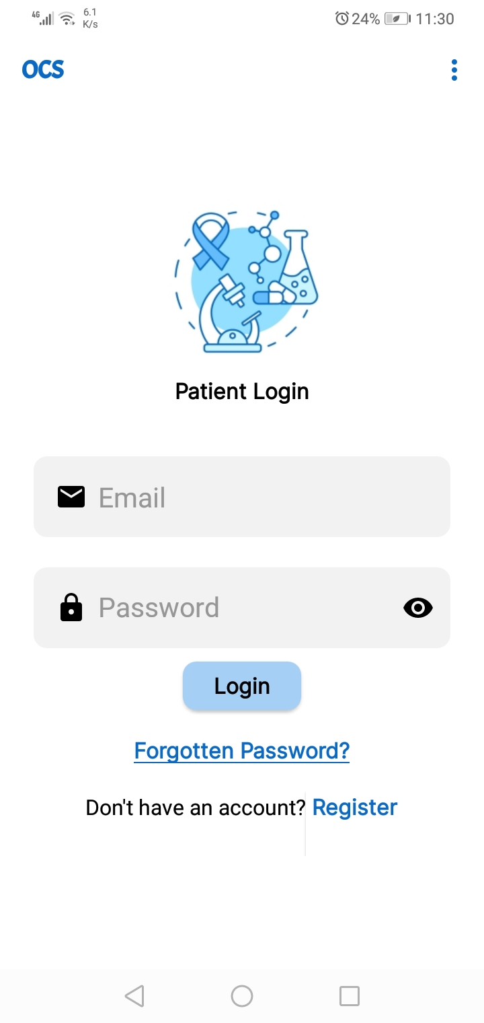

Figure 5\_16: Login Page

After patient register he can login to application by entering his Email and Password, after logged in he can view all services of system and use its functions easily.

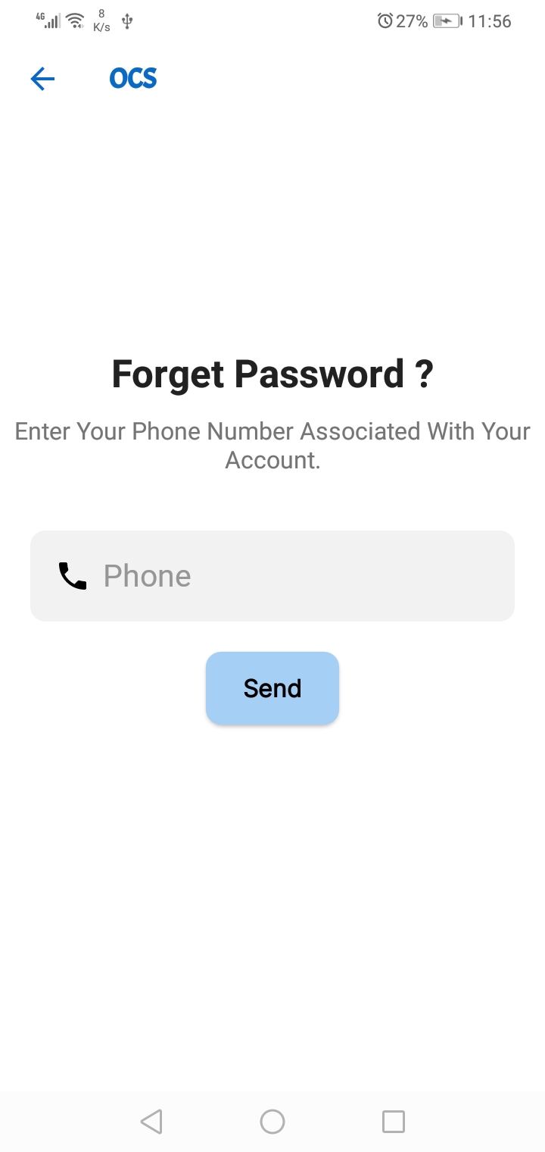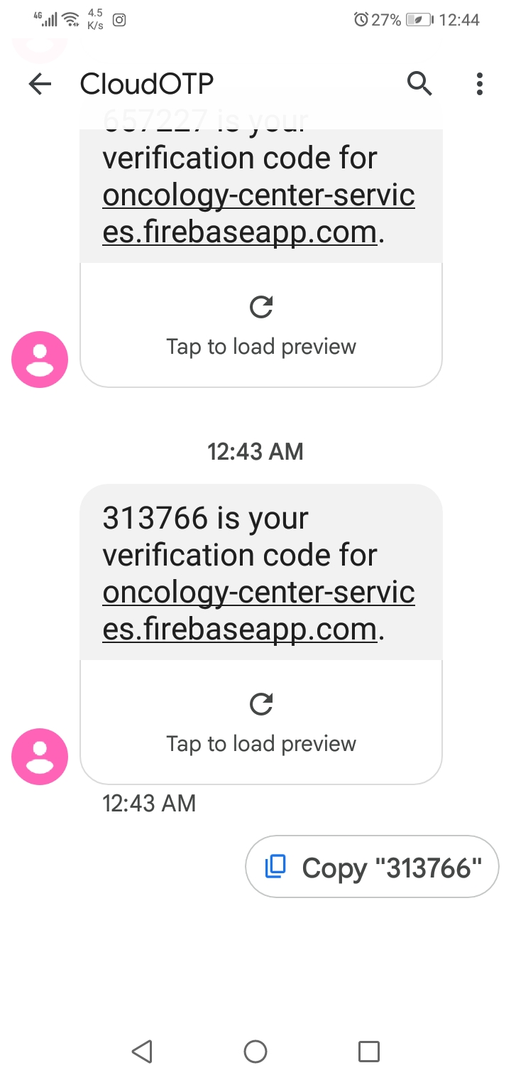

Figure 5\_17: Forget Password Page Figure 5\_18: Code Page

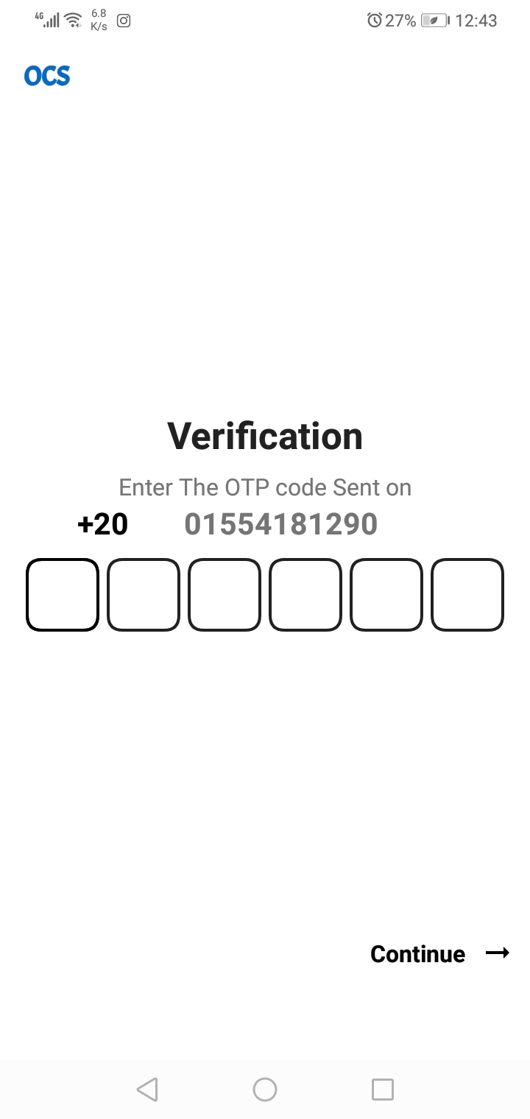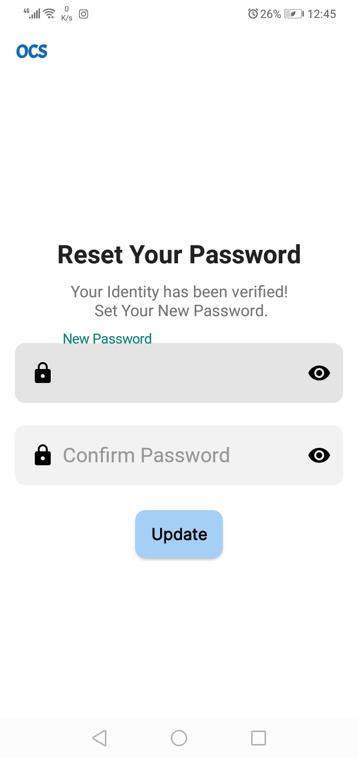

Figure 5\_19: Verification Page. Figure 5\_20: Reset Password Page.

When patient forgets his password he can click on forget password, Figure 5\_8 will appear and he should enter his number then system will send code to him as shown in figure 5\_9 then he should enter code in figure 5\_10 then figure 5\_11 will appear and he should enter new password.

### 5.4.3 Navigation

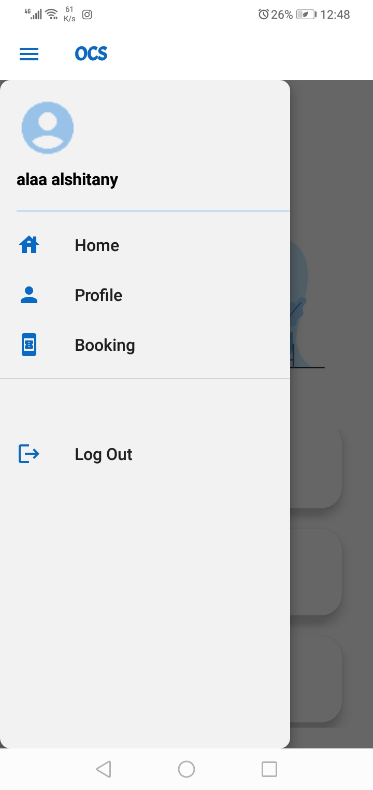

Figure 5\_21: Navigation Bar.

This page will appear when patient clicks on navigation bar, it contains home, Profile, and booking. Patient also can log out by clicking on logout, we will explain each of them in the following pages.

### 5.4.4 System Services (Home)

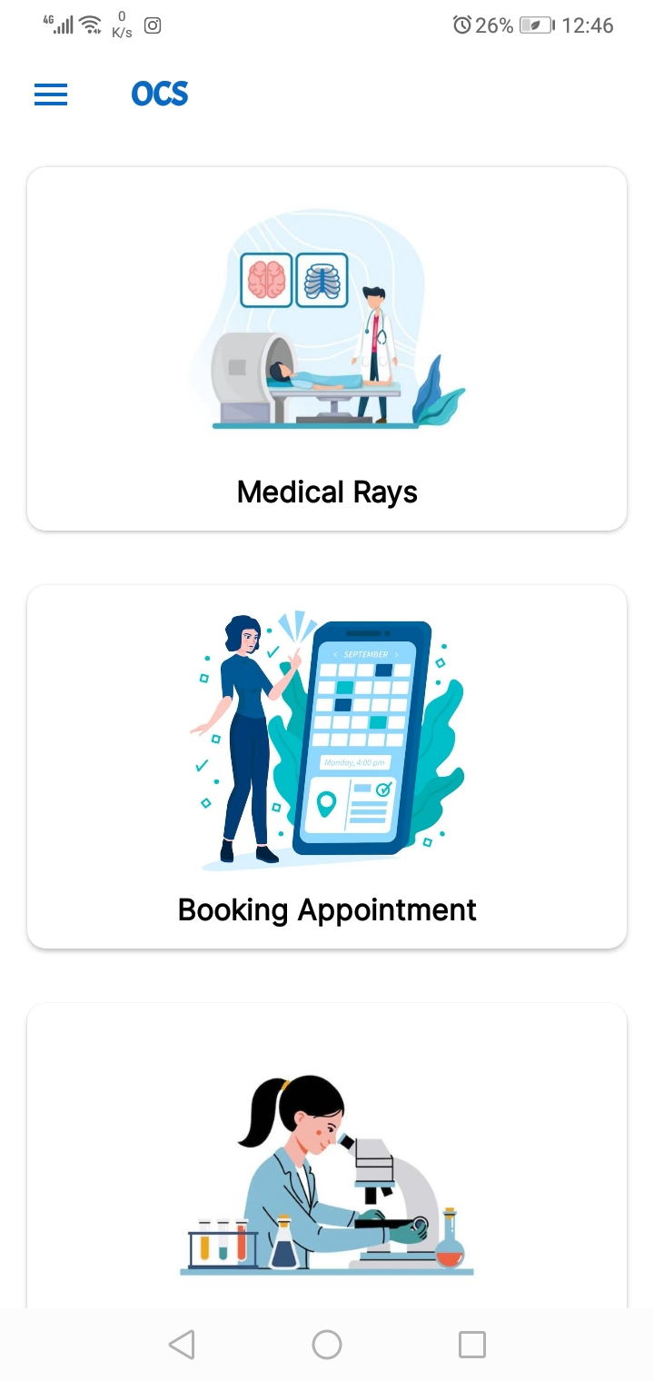 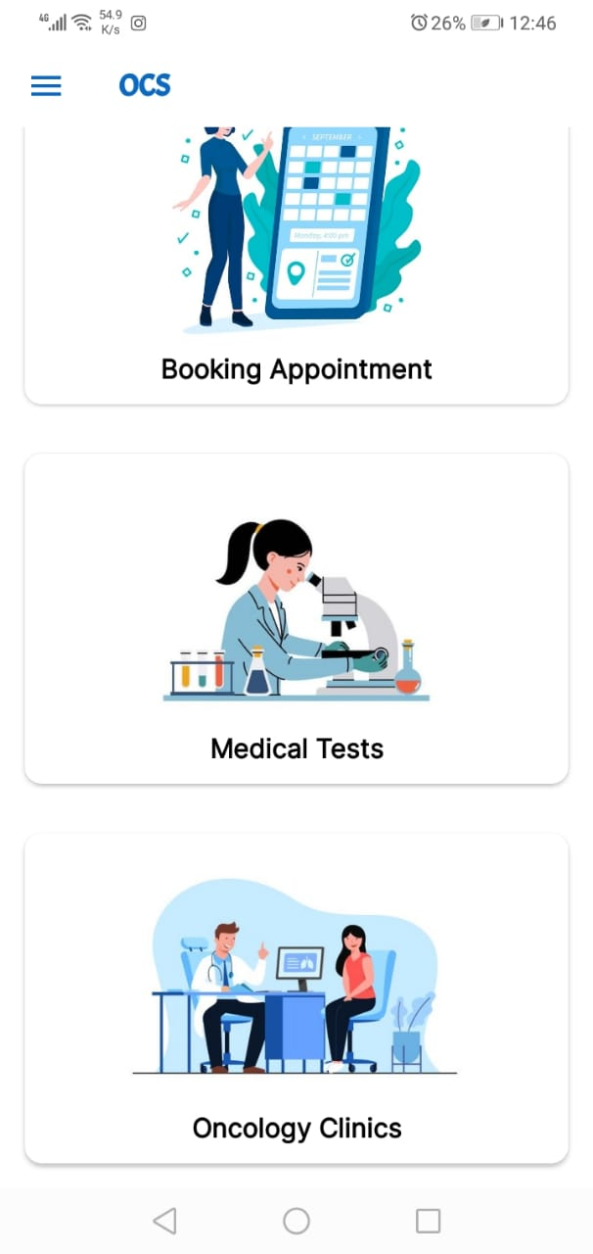

Figure 5\_22: Services Page1. Figure 5\_23: Services Page2.

After patient login to system, system services will appear as shown in figure 5\_12.Our system provides many services for patients such as (Medical Rays, Booking Appointment, Medical Tests, Oncology Clinics).

When patient click on each of them new page will appear, we will explain in the following figures.

#### 5.4.4.1 Medical Rays

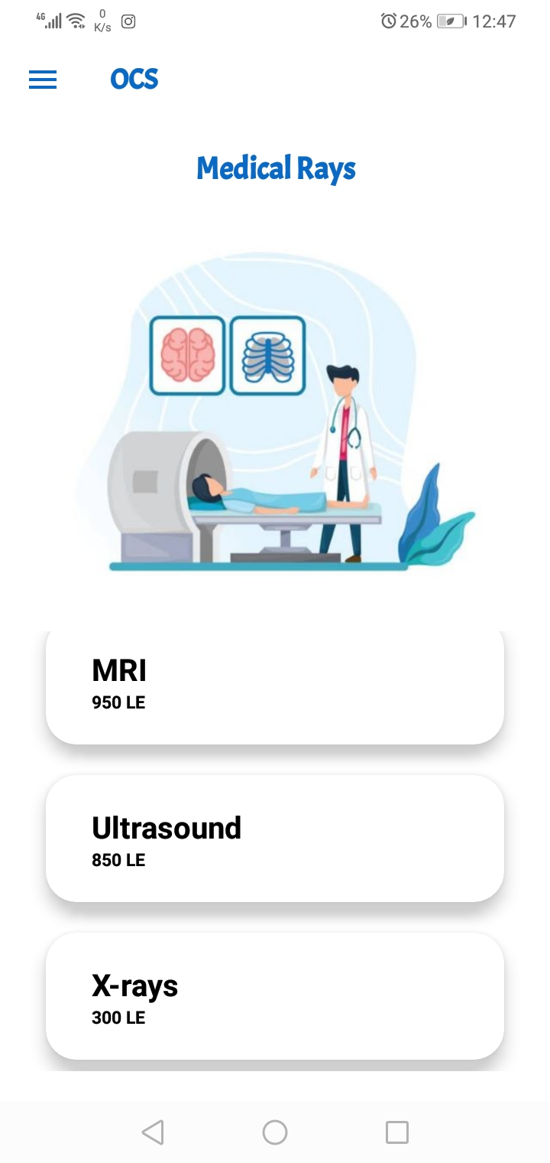

Figure 5\_24: Medical Rays.

This page will appear when patient click on Medical Rays on Services page, our system provides MRI, Ultrasound and x\_rays.

#### 5.4.4.2 Booking Appiontment:

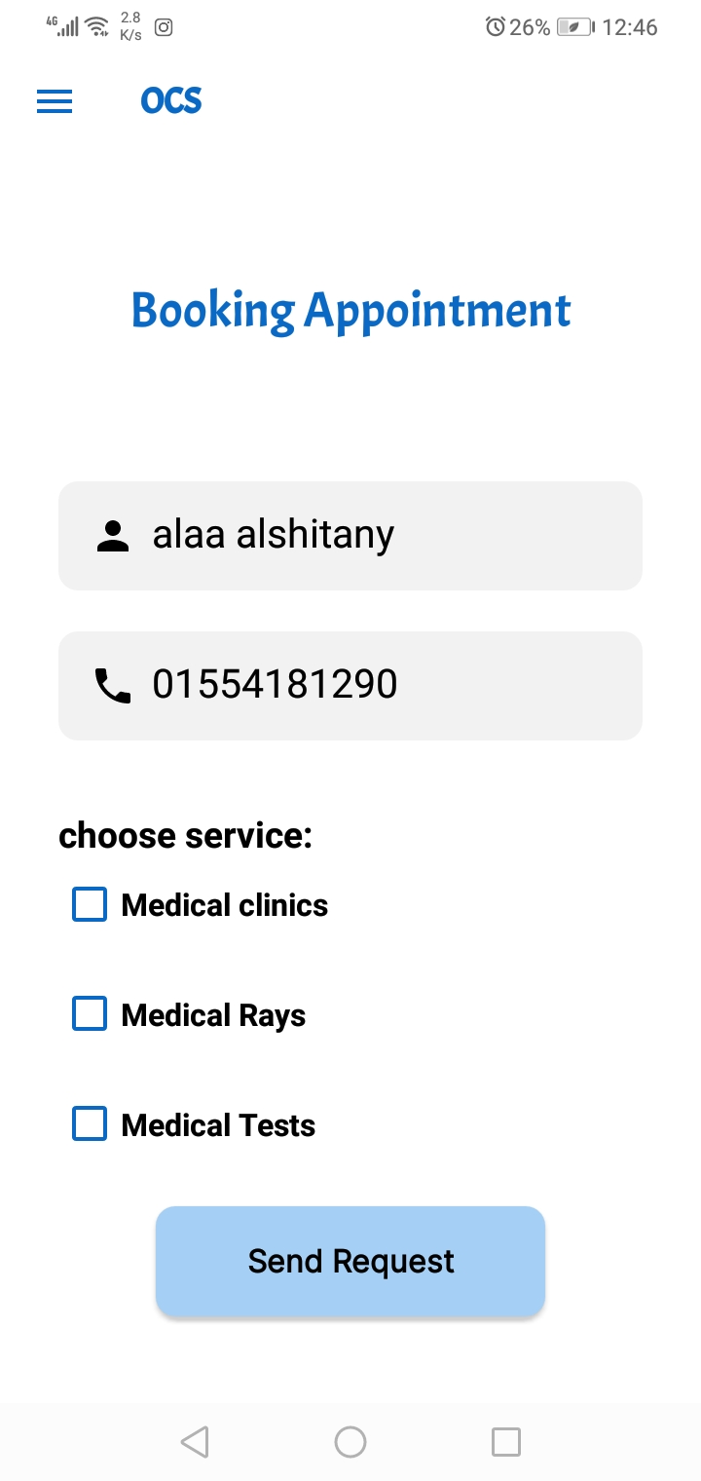

Figure 5\_25: Booking appointment.

When patient clicks on booking appointment in services page this page will appear, patient can book appointment by entering his name and phone then choose service he needs(Medical Clinics, Medical Rays, Medical Tests).

#### 5.4.4.3 Medical tests

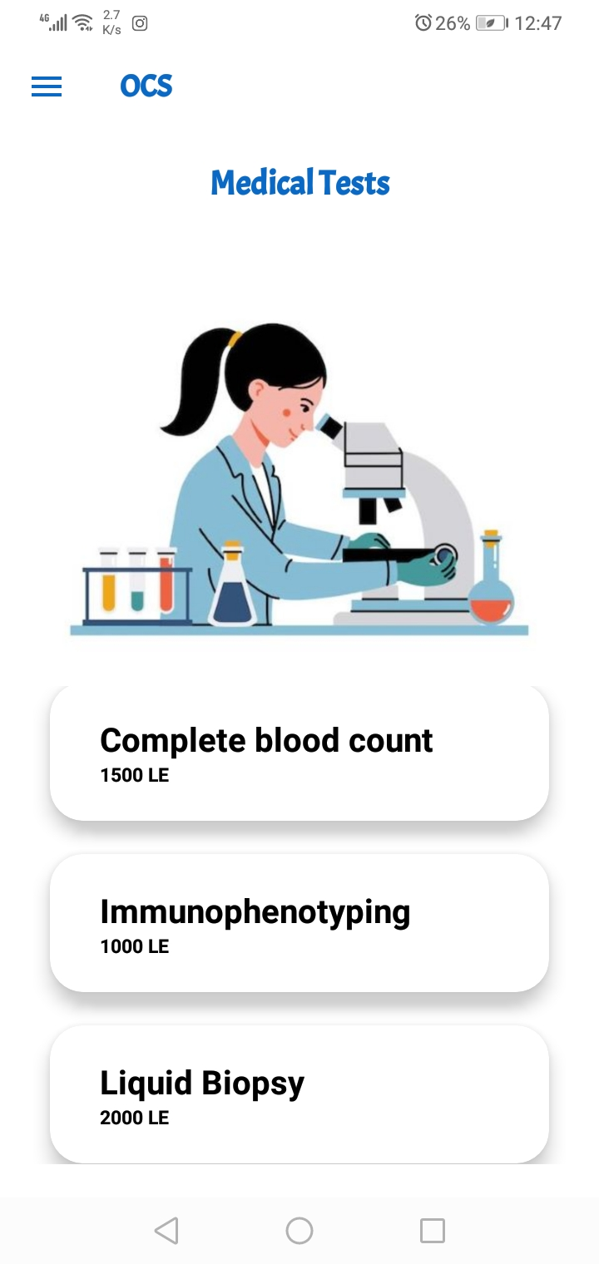

Figure 5\_26: Medical Tests.

This page will appear when patient click on Medical Tests on Services page, patient views our system tests (Complete blood count, Immunophenotyping, Liquid Biopsy) and their price.

#### 5.4.4.4 Medical clinics

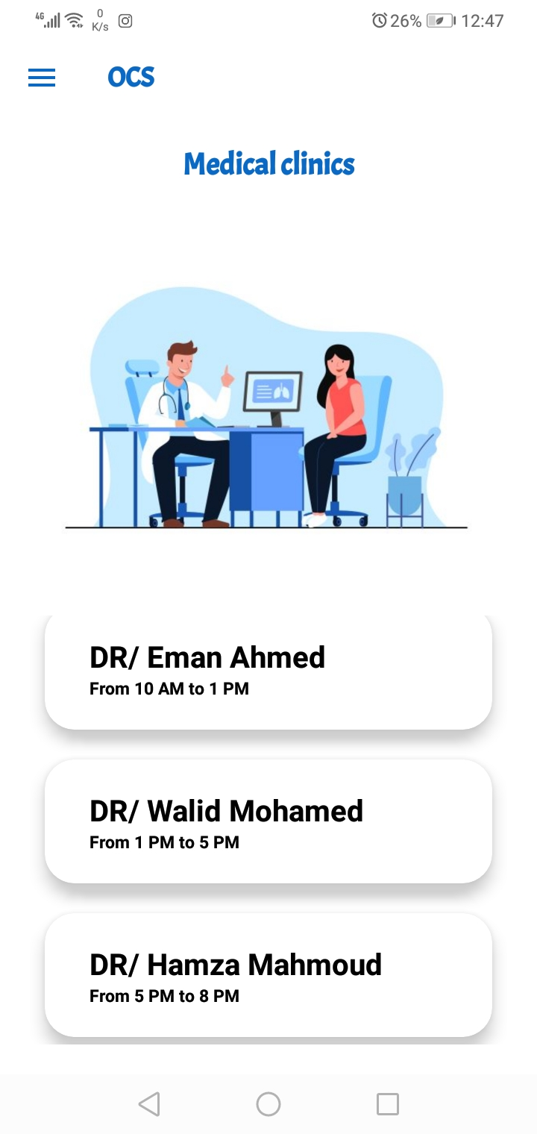

Figure 5\_27: Medical Clinics.

This page will appear when patient click on Medical Clinics on Services page, this page contains each doctor's information and appointments.

## 5.4 docyor pages

### 5.4.1 Doctor Login and Dashboard

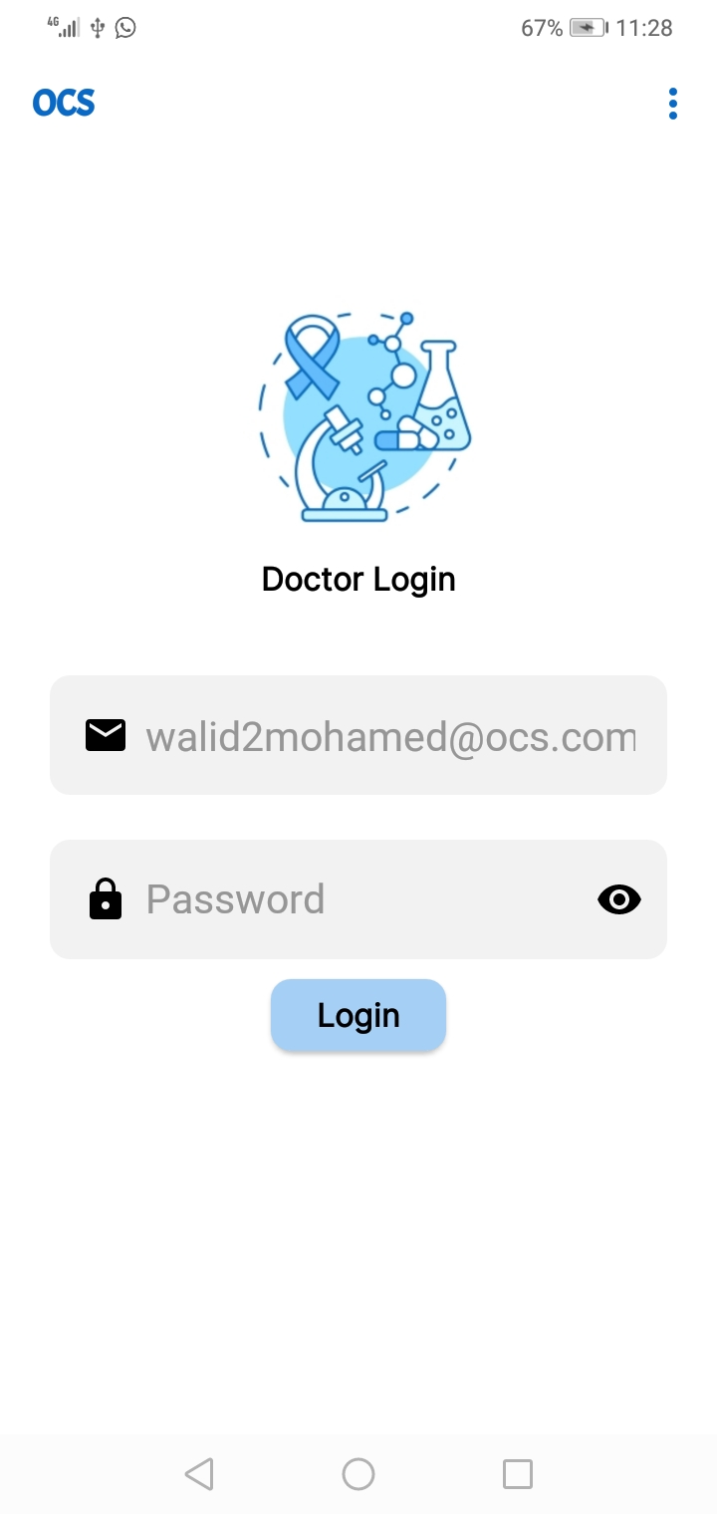 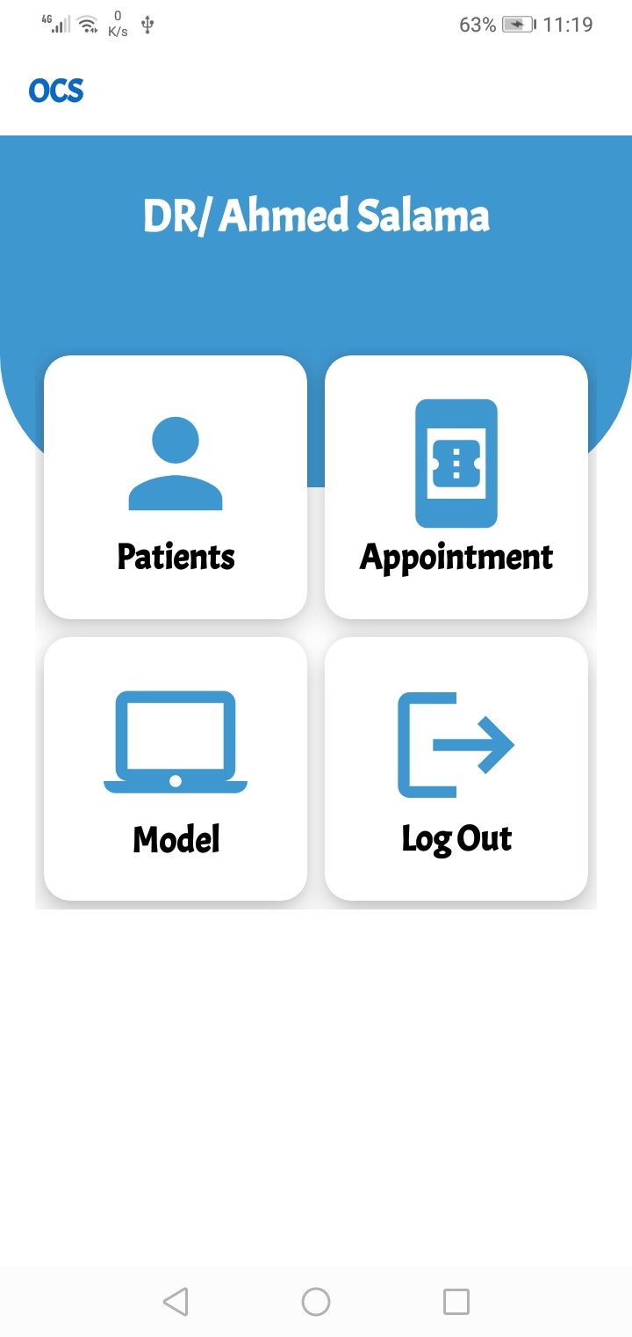

Figure 5\_28: Doctor Login. Figure 5\_29: Doctor Dashboard.

When doctor opens the system Figure 5\_28 will appear to him and he should enter his email and password which specified by admin, after he logged in dashboard will appear to him as shown in Figure 5\_29 from here he can manage patients as he can add or delete patients, he can view appointments, also he can use model to help him in prediction, we will explain each part.

### 5.4.2 Manage patients

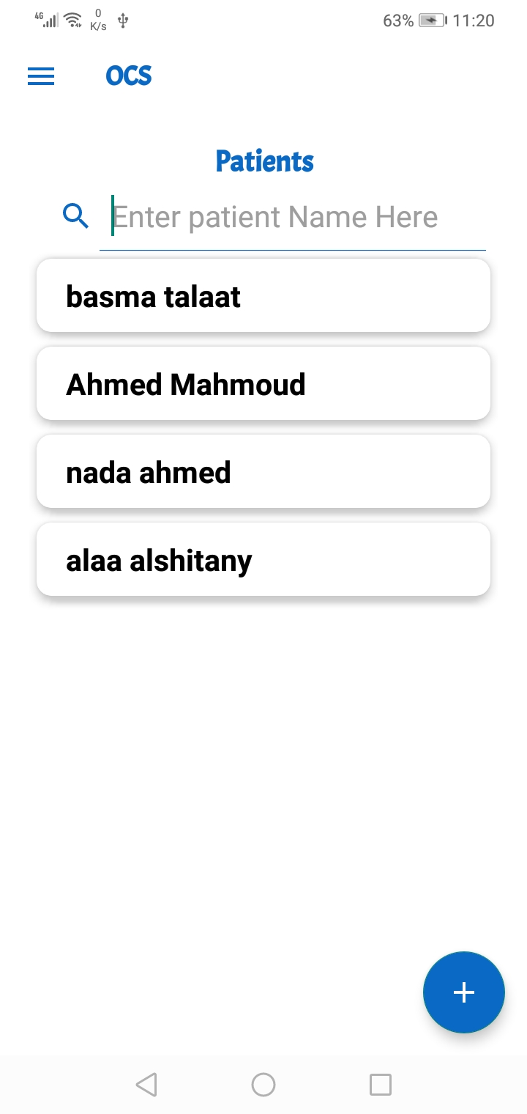 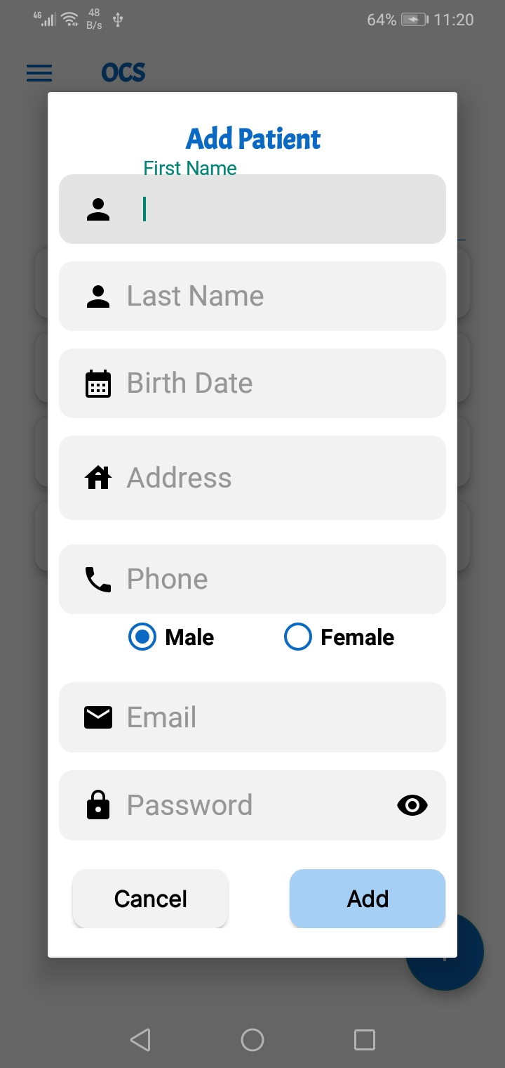

Figure 5\_30: Search Patient Page. Figure 5\_31: Add Patient Page.

Doctor can view Patients' names and search for a specific patient as shown in Figure 5\_30, if doctor needs to add patient he can click on plus sign, figure 5\_31 will appear, doctor will add patient information as shown in figure.

### 5.4.3 Appointments

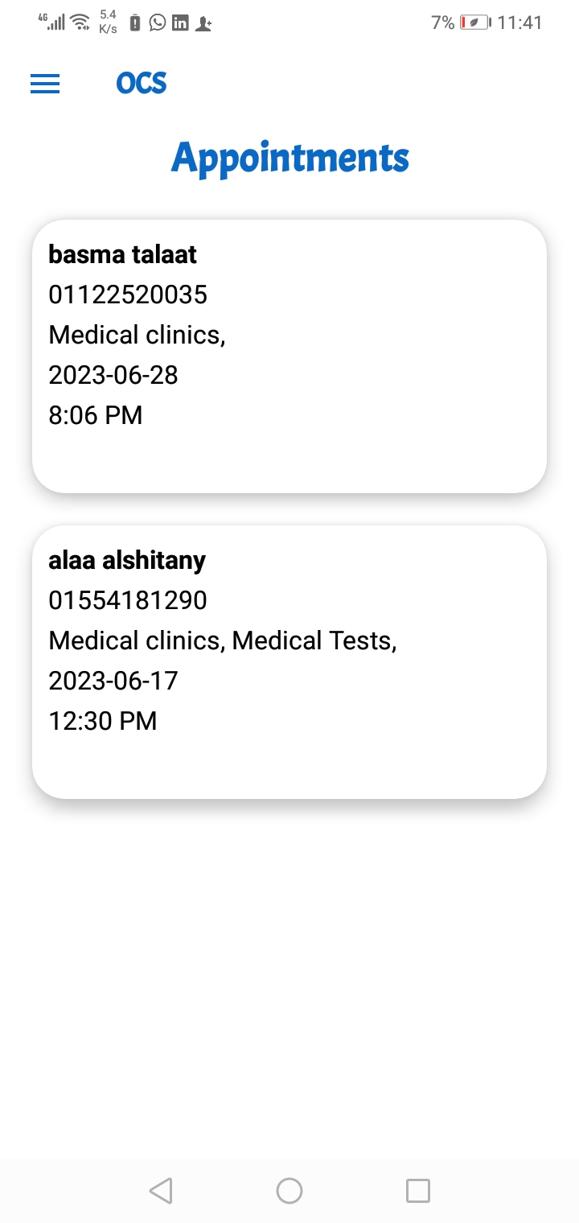

Figure 5\_32: Appointments Page.

Doctor can view appointments when clicks on appointments in dashboard as shown in Figure 5\_32, this page helps each doctor to his appointments.

### 5.4.4 Model

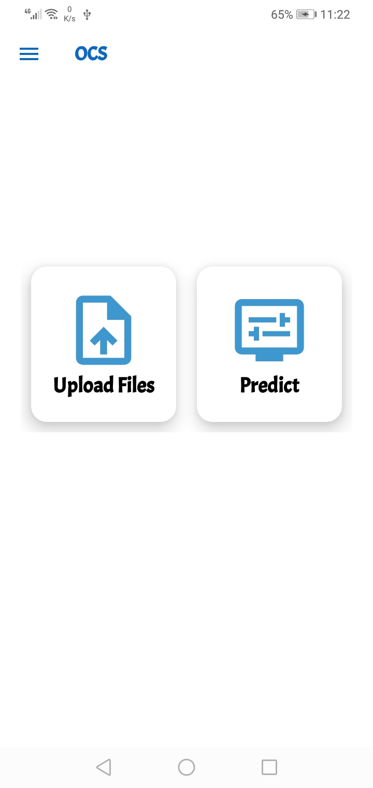

Figure 5\_33: Model Page.

This is the most important part in our system as from this page doctor can upload files of patient and file of drug then the model will predict the sensitivity or resistance of drug.

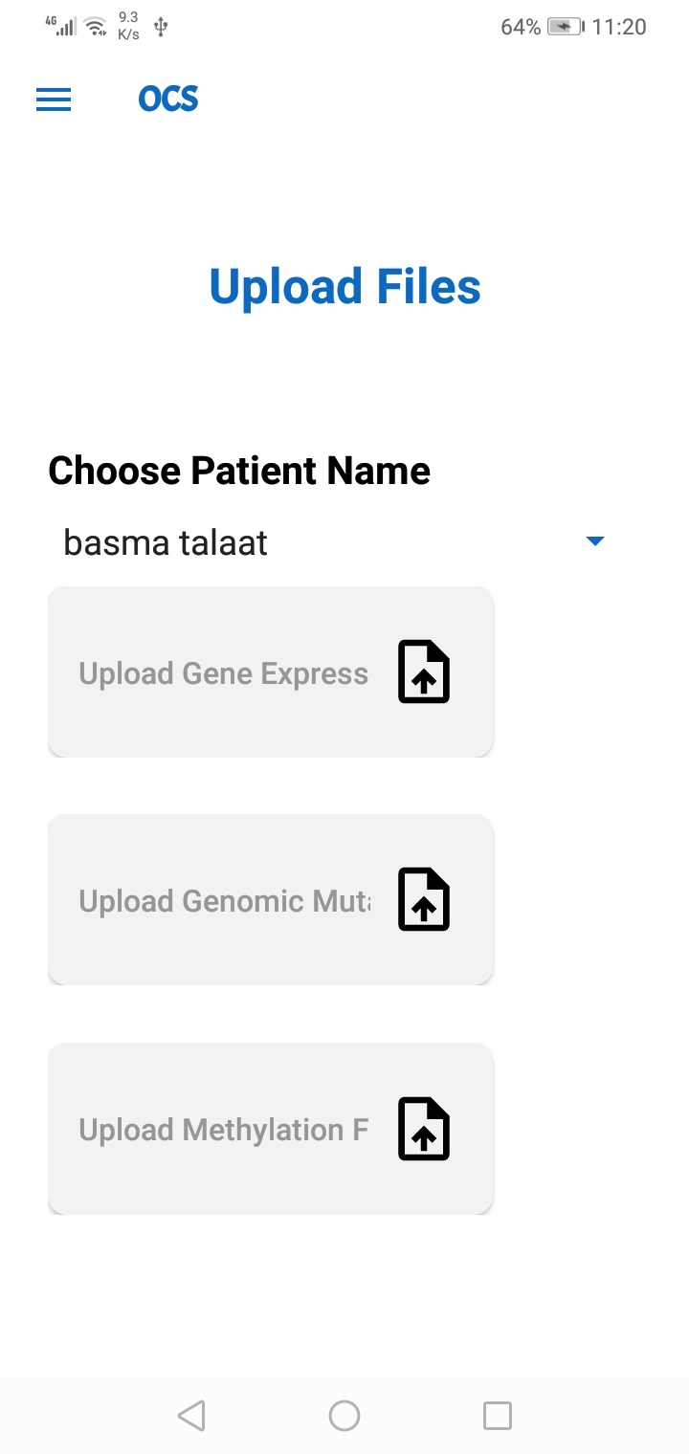 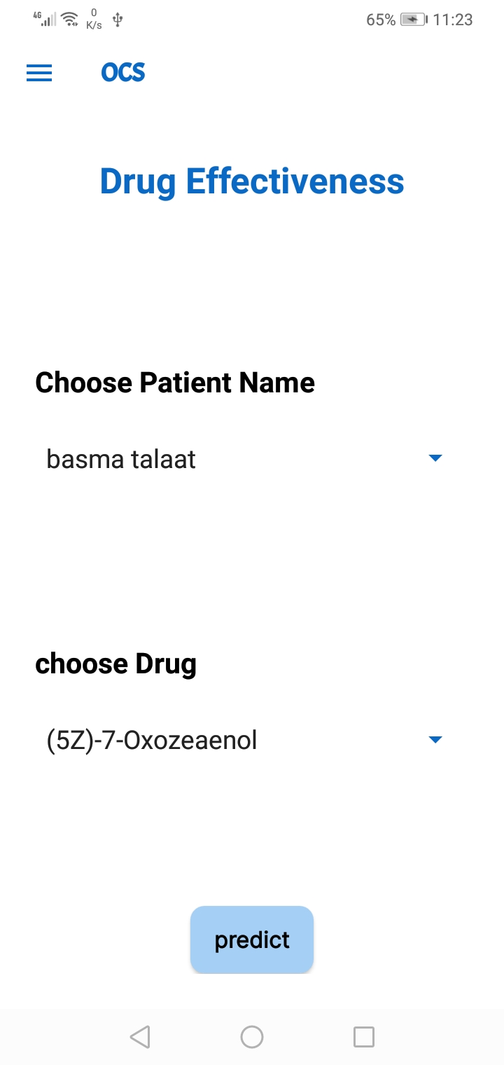

Figure 5\_34: Upload files Page. Figure 5\_35: Choose drug Page.

In Figure 5\_34 doctor will upload files of patients which contain his genomic information (genomic expression file, genomic mutation and genomic methylation), then from next page (Figure 5\_35) doctor will choose drug name then click predict.

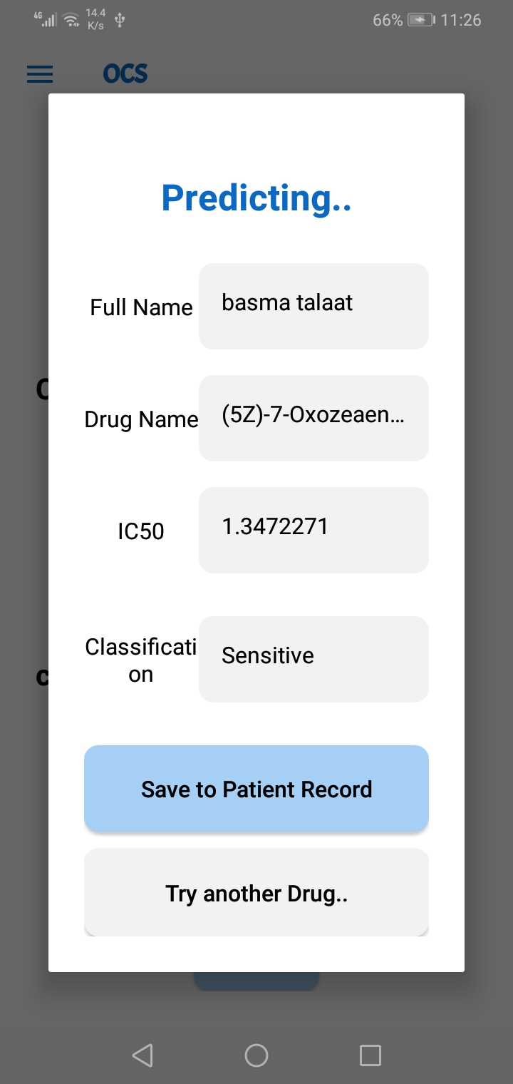

Figure 5\_36: Predicting Page.

This page appear after clicking predict in previous figure, it contains Patient name, drug name, IC50 value and classification result (sensitive or resistance).Doctor can save prediction result in patient record, if he want to try another drug he can click on try another drug button.

# Conclusion

Diagnosing and treating cancer is not easy and needs the most effective tools to help doctors and patients. OCS is an app we developed to help in the field of cancer, and we hope it helps. We used deep learning techniques such as CNN and GCN. OCS can be presented as an application to explore drug sensitivity using large-scale, multistage cancer profiles. OCS outperforms several baselines, and our analysis demonstrates how our method can help prioritize therapeutic targets for anticancer drug discovery. And we have targeted Android devices for this application because most of the people in the world are using Android system, so the application will be more widely used and widespread, Which will facilitate the reservation process for the patient and save him a lot of time, and it will also be useful for the doctor, as it will help him in treatment and take the correct action for the patient by knowing whether the medicine will be effective with the patient or not.

# Chapter 6

## 6.1 Parts Of Code

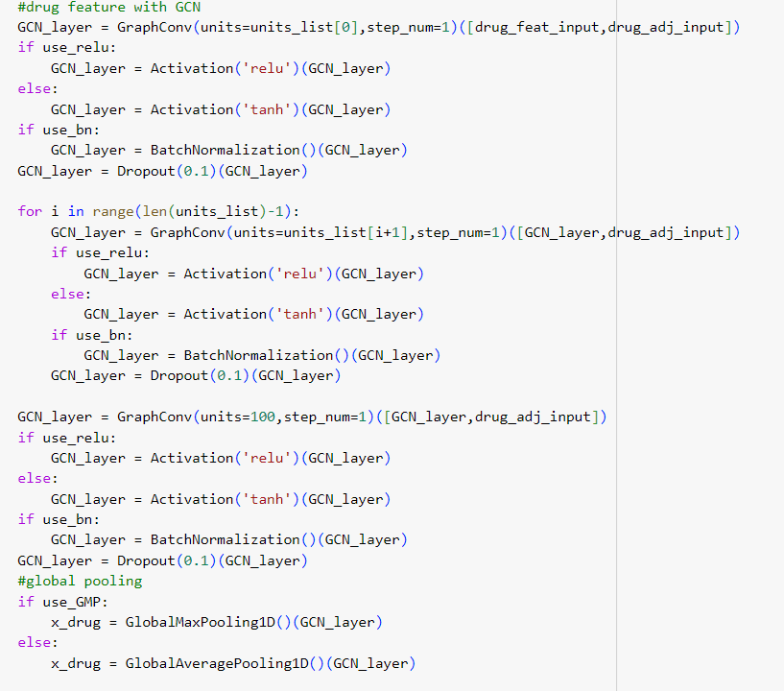

Figure 6\_1: GCN Layers.

The first GCN layer takes the drug feature input and the adjacency matrix input as inputs and applies a graph convolution with units\_list[0] number of hidden units. The output tensor is then passed through an activation function (RELU), a batch normalization layer (if use\_bn is True), and a Dropout layer. Subsequent GCN layers take the output tensor of the previous layer and the adjacency matrix input as inputs and apply another graph convolution with units\_list[i+1] number of hidden units. The output tensor is then passed through the same sequence of activation, batch normalization, and Dropout layers. The final GCN layer applies a graph convolution with 100 hidden units and follows the same sequence of activation, batch normalization, and Dropout layers. The output tensor of the final GCN layer is then passed through a global pooling layer (either GlobalMaxPooling1D or GlobalAveragePooling1D, depending on the use\_GMP parameter) and concatenated with the other features.

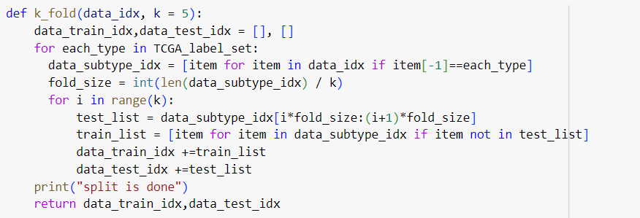

Figure 6\_2:Train\_Test\_Split

This code defines a function Data Split that splits a list of data indices into training and testing sets for each subtype in a given label set. The function takes two parameters: data\_idx, which is a list of data indices, and ratio, which is the proportion of data to use for training (default value is 0.80).

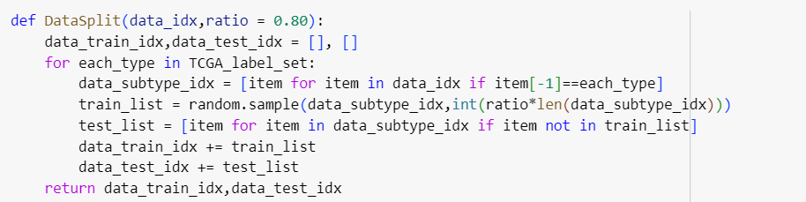

Figure 6\_3:K\_Fold

This code defines a function k\_fold that performs k-fold cross-validation on a list of data indices for each subtype in a given label set. The function takes two parameters: data\_idx, which is a list of data indices, and k, which is the number of folds to use for cross-validation (default value is 5).

## 6.2 Run Screens

We use Colab Pro to run our model.

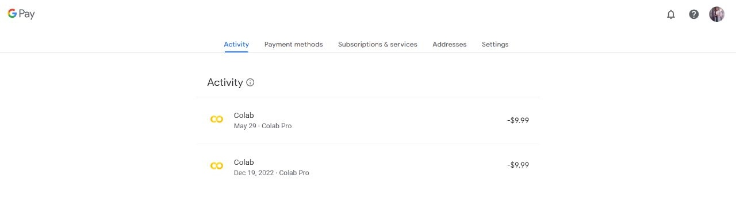

Figure 6\_4: Colab Pro

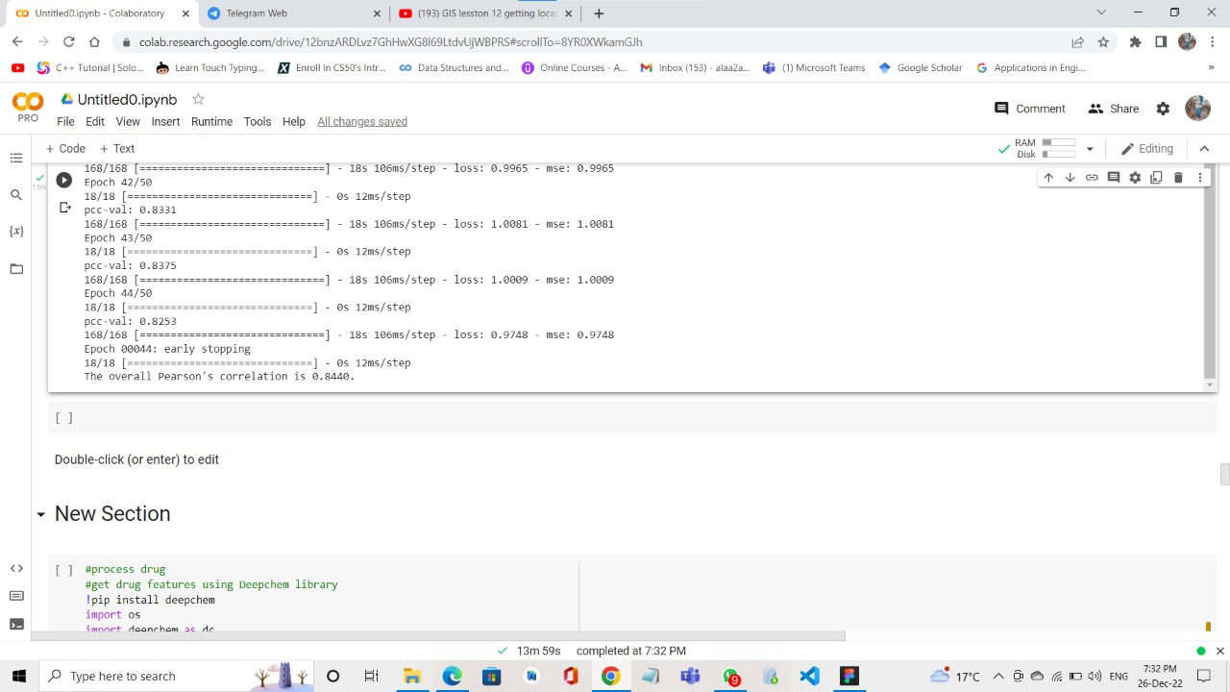

Figure: 6\_5 Run of classification (Train\_Test\_Split).

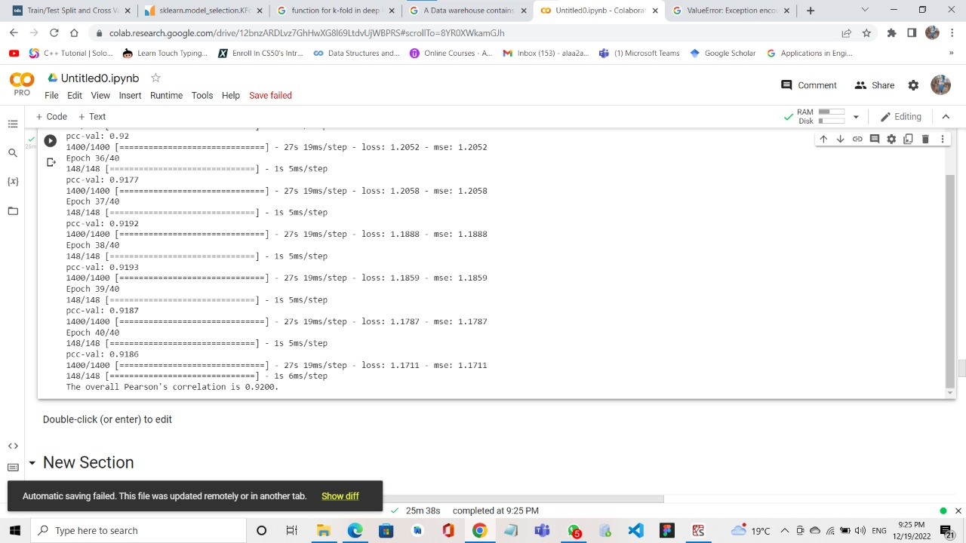Figure: 6\_6 Run of Regression (Train\_Test\_Split).

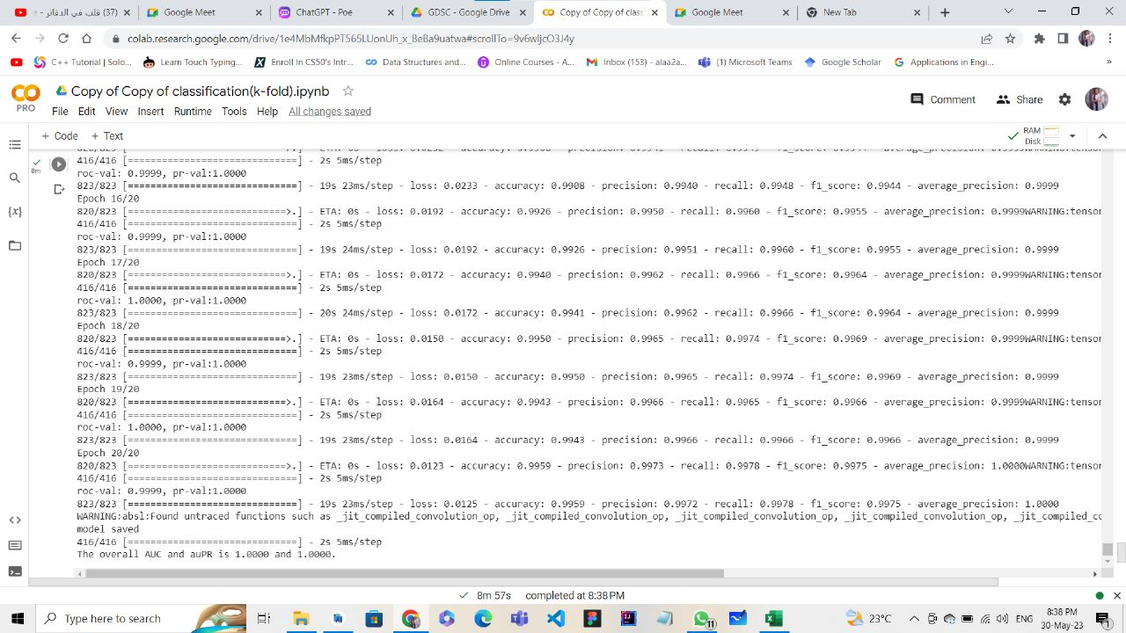

Figure: 6\_7 Run of classification (K\_Fold).

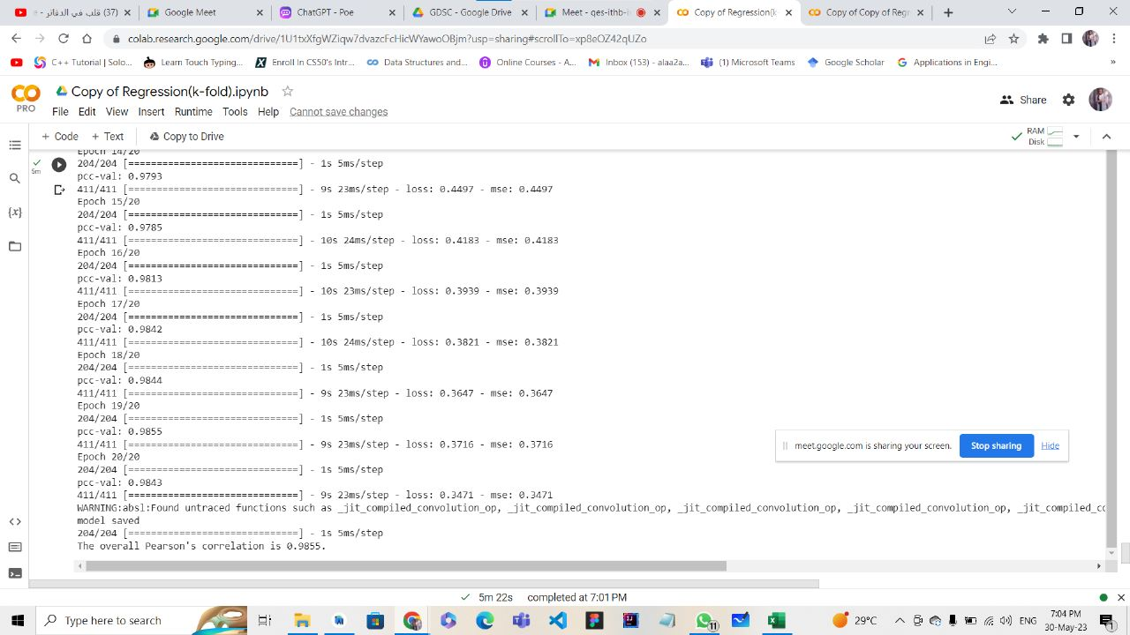

Figure: 6\_8 Run of Regression (K\_Fold).